Time interval* | WBD availability/chorus
7-9 January 2008 | 6,8,9 January (Chorus/MP/MSH)
13-16 January
1-3 February | 1 February (Chorus/North Auroral Zone)
10-13 February
29 February- 3 March | 27 Feb (Cusp)
9 – 12 March | Currently studied by the FST Team
29-31 March | 29 March (Cusp/North Auroral Zone)
5-9 April
23-25 April
15-18 June
13-16 July
23-26 July
10-14 August
12-15 October

*electron fluxes at GOES reach 10⁴ #/(cm² sec str) or higher
Most intense events indicated in red

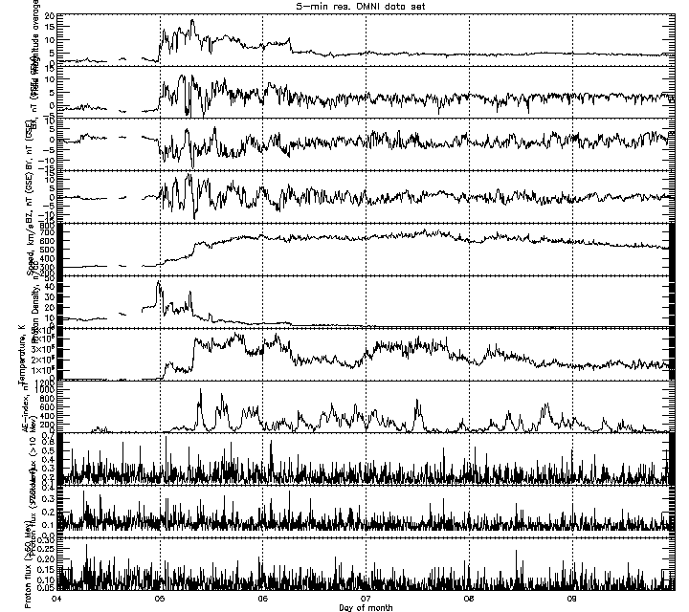

2008/0104-0109 (mmdd1-mmdd2)
OMNI plots (5-min averages) have the following panels (top to bottom):
B,Bx,By,Bz – GSE
V_flow, N, T
AE index
GOES : Proton Flux >10 MeV, 1/(cm**2-sec-ster), >30 MeV, >60 MeV

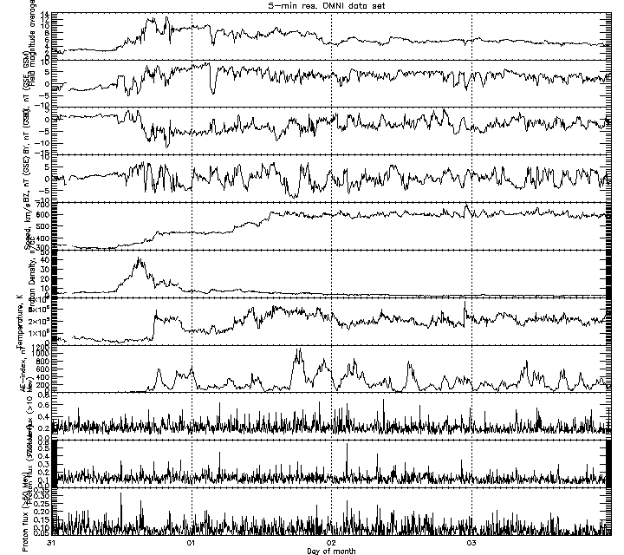
2008/0131-0203

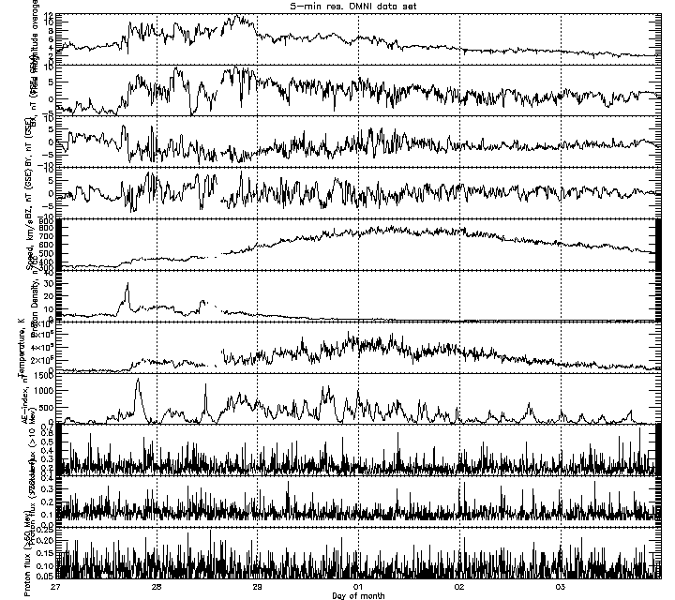

2008/0227-0303

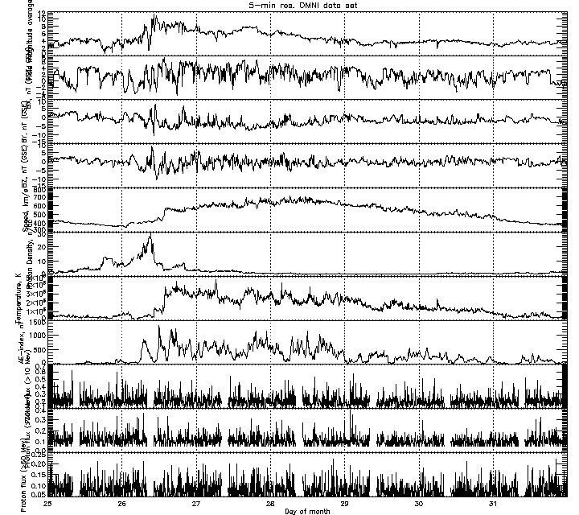

2008/0325-0331

