User Guide to
the WBD Measurements
in the Cluster Science Archive (CSA)

prepared by

Jolene S. Pickett (pickett@uiowa.edu)
Roxane M. Mitten (roxane-mitten@uiowa.edu)
Ivar W. Christopher (ivar-christopher@uiowa.edu)
Joanne M. Seeberger (joanne-seeberger@uiowa.edu

The University of Iowa
Department of Physics and Astronomy
Iowa City, Iowa, 52242, USA

and

J. Soucek (soucek@ufa.cas.cz)
O. Santolik (os@ufa.cas.cz)
M. Hayosh (hayosh@ufa.cas.cz)

Institute of Atmospheric Physics
Czech Academy of Science
Bocni II 1401, 141 00 Praha 4, Czech Republic

and

Keith Yearby (k.h.yearby@sheffield.ac.uk)
Simon Walker (simon.walker@sheffield.ac.uk)

The University of Sheffield
School of Electrical and Electronic Engineering
Sheffield, UK

Table of Contents

1 Introduction 2
2 Instrument Description 3
3 Instrument Operations 7
4 Measurement Calibration and Processing Procedures 9
5 Key Science Measurements and Datasets 11
5.1 Introduction 11
5.2 Overview Spectrograms 11
5.3 High-Resolution Spectrograms 14
5.4 High-Resolution Waveform Data 15
5.4.1 Description of WBD CEF files 15
5.4.2 WBD CEF versus CDF files 18
5.4.2 Level 1 data files 18
6 Recommendations 18
7 References 19
8 Appendix 1: Special science operations 20
8.1 WBD/WHISPER/PEACE non-thermal continuum operations 21
8.2 WBD/PEACE Chorus operations 21
8.3 Other special operations 26
8.3.1 HAARP OPERATIONS 27
8.3.2 IMAGE/RPI OPERATIONS 28
8.3.3 WHISPER MUTUAL IMPEDANCE TEST 29
9 Appendix 2: Interpretation issues 29
CLUSTER WBD INTERPRETATION ISSUES 30
Electron Drift Instrument (EDI) 30
Receiver Gain Effects for Wide Band Data Instrument (WBD) 32
Spacecraft Battery Interference 34
Spacecraft Power Bus Interference 35
WHISPER Sounder Instrument Interference 36
900 Hz Clock Effects for the Digital Wave Processor (DWP) 40
Interference from Electric Field Antennas 41
Instrumental Effects: Waveform Distortion 45
Instrumental Effects: Harmonic Generation 45
Saturation of Magnetic Field Data at Low Altitude 47
High Noise Floor on Cluster Spacecraft 1 Since November 30, 2009 49

1 Introduction

This User Guide to the Cluster Wide Band Data (WBD) data will provide the basic information needed by any scientist, data analyst or computer programmer to use the WBD data archived at the Cluster Science Archive (CSA). It describes the WBD instrument, its operating modes, and the data produced thereby. The WBD technique involves transmitting band-limited waveform (time series) data, in real time, to a NASA DSN or Czech Panska Ves ground station using a high-rate data link. This is the unique aspect of the WBD instrument since all other Cluster data are obtained and stored onboard for later playback to a receiving antenna on the ground. The primary advantage of the WBD approach is that complete, high-resolution, electric or magnetic field waveforms are available along one axis for detailed time and/or frequency analysis. Because of this high time resolution aspect of the WBD data (~5 to 36 microseconds resolution), the WBD team warns the user that the data volume is large. Another unique aspect of the WBD instrument is that it can be commanded to different frequency ranges, allowing it to better target various types of plasma waves observed throughout Cluster’s orbit at vastly different frequencies, e.g., auroral kilometric radiation at frequencies greater than 125 kHz vs. whistler mode chorus waves at frequencies of a few hundred Hz to ~ 8 kHz.

Because the WBD measurements are telemetered at high data rates to ground stations, WBD’s operations are constrained to times when ground station resources are available and the spacecraft are visible to that ground station. Thus, the WBD data are obtained during only small parts of any one orbit (~4%) targeted for the science investigation to be carried out (e.g., magnetopause, auroral acceleration region, bow shock, etc.). Further, data may be obtained on all 4 spacecraft, or fewer spacecraft (sometimes only one). Because of this, it is necessary to download the WBD documents which detail when data were taken and in what mode. More will be said about this below.

For completeness, we note here that WBD data can also be obtained in a mode called Burst Mode 2 (BM2), stored onboard, and transmitted to the ground with the data from all the other instruments. This mode was rarely used up to July 2010 (only once on March 7, 2001), but more often thereafter (typically 2-4 four-spacecraft operations per month) to obtain data at low altitude or in the high priority auroral acceleration region), because it results in decreased bandwidth or a higher degree of duty cycling for WBD.

2 Instrument Description

The Wideband Data (WBD) Plasma Wave Investigation for Cluster provides wideband (bandwidths up to 77 kHz) waveform measurements of plasma waves in the Earth's magnetosphere. A Wideband Receiver system which measures electric and magnetic fields over the frequency range 100 Hz to 577 kHz is provided by the WBD investigation as part of the Wave Experiment Consortium (WEC) instrumentation.

The WBD instrument processes signals obtained either from one of two spin-plane electric dipole antennas, or from one of two magnetic search coils (one with its axis in the spin plane, and one with its axis along the spin axis of the spacecraft) as shown in Table 2.1. The antennas are a part of the electric (EFW) and magnetic (STAFF) field experiments, respectively. The electric antenna subsystem provides signals up to almost 600 kHz, while the magnetic subsystem provides signals up to around 4 kHz. At any given time, only electric or magnetic data are provided by WBD. The antenna used to make a WBD measurement will be designated by a byte 0 through 3 in the WBD waveform files archived at the CSA (files are in CEF format, and will be referred to as CEF files hereafter—see section 5 below), as shown in Table 2.1.

Table 2.1. Antennas Used for Signal Input
Antenna | Designation in CEF Files | Measurement Location
Ez (EFW probes 1 and 2) | 0 | In Spin Plane
Ey (EFW probes 3 and 4) | 3 | In Spin Plane
Bx | 1 | Along Spin Axis
By | 2 | In Spin Plane

There are three frequency bandwidths possible for WBD measurements. These three bandwidths are shown in Table 2.2, along with the effective bandwidth provided by each band. The full bandwidth on the low frequency side (down to 0 kHz) is not possible since various filters are employed in the WBD and antenna designs to filter out the DC electric and magnetic fields. Although wave emissions are sometimes observed in the WBD data spectrograms at frequencies above and below the effective bandwidth ranges, the calibration at these frequencies is not valid although the emissions are present at their proper frequencies. There are also four translation modes possible for WBD measurements, three of which allow data to be taken in bands that start at one of three higher frequencies, instead of at 0 kHz. These approximate translation modes are shown in Table 2.3, along with their precise translation frequency (note that the “precise” translation frequencies are provided in the CEF files). The clocks employed in the Cluster Onboard Data Handler did not allow for the precise frequency shifts to be round numbers, such as 125 kHz, so the precise translations must be used when analyzing data from translation modes other than zero (also known as Baseband). These three non-zero translation modes use a combination of filters to down-convert the analog signal from the higher frequency band down to one based at 0 kHz, after which it is further processed (digitized, etc.) just as a baseband signal would be. The down-conversion process preserves the frequency information in the signal (as displayed in a spectrogram, for instance), but users of waveform data should note that it does not preserve the shape of the original waveform. See the WBD Caveats document (found in the “Documentation” section of the CSA) for a further explanation.

Table 2.2. WBD Frequency Modes Table 2.3. WBD Translation Modes

Bandwidth (kHz) | Effective Bandwidth (kHz)
9.5 | 0.1 - 9.5
19 | 0.1 – 19.0
77 | 0.7 – 77.0

Approximate Translation Frequency (kHz) | Precise Translation Frequency (kHz)
0 (Baseband) | 0
125 | 125.454
250 | 250.908
500 | 501.816

As an example of how to understand the information contained in Tables 2.2 and 2.3, WBD often operates in a mode in which auroral kilometric radiation is expected to be observed, say around 270 kHz. To observe this emission WBD would be commanded in the 77 kHz bandwidth mode with a translation of 250.908 kHz. This means that the waves are being detected in the effective frequency band of 251.608 kHz (0 + 250.908 + 0.7) to 327.908 kHz (0 + 250.908 + 77.0), where the values in parentheses consist of the base frequency (always zero) plus the actual translation frequency plus the effective bandwidth, lower and upper edge, respectively.

Note that for magnetic data, only the 0 kHz translation, 9.5 kHz bandwidth mode is ever used, and even then, natural signals can only be calibrated up to 4 kHz, the upper limit of the STAFF search coils. Refer to the WBD Calibration Report for more information on this issue.

The final analog step in the signal processing path is an incremental automatic gain control (AGC), which adjusts the signal to an optimal level in steps of 5 dB over a range of 0 dB to 75 dB (16 possible gain values, 15 possible steps). For most of the mission, the AGC has been set to update at its fastest rate, which adjusts the gain every 0.1 seconds, if necessary. From Feb. 1 – Dec. 23, 2001, however, the gain update rate was set to once per second for all measurements and continued to be set at this rate for AKR-VLBI (Auroral Kilometric Radiation/Very Long Baseline Interferometry) targeted measurements until Oct. 23, 2005. Note that the gain update rate is not included in the WBD data stream and thus not archived with the WBD data, but could be obtained from the archived DWP engineering data. CAUTION: The user is referred to the WBD Caveats document with regard to the possibility that 1) a gain change could be reported to have occurred prior to its actual occurrence, and 2) the last gain value will be repeated for up to ~5 s in BM2 when WBD gain information is lost due to sampling data from the Whisper instrument for short intervals of time.

The output signal is then digitized, with 1-bit, 4-bit, or 8-bit resolution. Although 8-bit resolution is preferable, 4-bit and 1-bit options were provided in order to obtain continuous sampling in the 19 and 77 kHz bandwidth modes as shown in Table 2.4. Any of the bandwidth and resolution modes listed in this table can be combined with any frequency translation.

Table 2.4. WBD Output Modes
Bandwidth (kHz) | Sample Rate (kHz) | Resolution (Bits/ Sample) | Duty Cycle  (%) | Comments
9.5 | 27.443 | 8 | 100
19 | 54.886 | 4 | 100
19 | 54.886 | 8 | 50 | Note a
77 | 219.544 | 1 | 100
77 | 219.544 | 4 | 25 | Note c
77 | 219.544 | 8 | 12.5 | Note b

Notes: (a) 2180 samples equal to 39.719 msec of data followed by 39.719 msec of data gap.
(b) 2180 samples equal to 9.9230 msec of data followed by 69.508 msec of data gap.
(c) 4360 samples equal to 19.859 msec of data followed by 59.578 msec of data gap.

Thus, the user is cautioned to read all of the WBD status bits and to note which modes in Table 2.4 are not continuous data, but rather duty cycled, with the details of that duty cycle given in the applicable notes.

Note that WBD also has a burst mode (BM2) capability that allows reduced resolution data (decreased bandwidth or increased duty cycling) to be stored on the spacecraft for later transmission to the ground. This mode has been used only sparingly during the mission though (once on Mar. 7, 2001, and more often after July 28, 2010 in order to obtain data at very low altitudes, i.e., several 100 to 2500 km, and in regions of high scientific priority such as the auroral acceleration region), as it reduces, and in some cases eliminates, all concurrent telemetry from the other instruments. Direct transmission of WBD data to the ground stations at these low altitudes is prohibited by international agreements governing electromagnetic transmission signal power. Thus, the only way to obtain WBD wave data at these altitudes is through the onboard BM2 mode.

For more information on the WBD instrument, the user is referred to Section 7 where all of the pertinent references which provide information about the WBD instrument are provided.

3 Instrument Operations

Since most of WBD data are acquired via a real time downlink to NASA Deep Space Network ground stations in California (Goldstone), Australia (Canberra), and Spain (Madrid) and the Czech Republic ground station at Panska Ves, the main constraints on when these data are obtained are the availability of ground station resources and visibility of the spacecraft to those stations. For this reason, there are usually only about 35 to 45 hours of WBD data acquired, over all four spacecraft (as opposed to on each), during any given week. These data periods may consist of overlapping multi-spacecraft operations, or may involve only a single spacecraft. WBD passes can be as short as ~10 minutes and as long as 5+ hours. Typical passes are 1-2 hours long.

NASA’s Deep Space Network terminated WBD data acquisition on February 6, 2015 and after that date WBD operations are limited to Panska Ves real time downlink (limited to altitudes below about 11 RE with one 10m antenna and below 14 RE with two 10m antennas) and a limited number of BM2 operations. This resulted in a decreased total weekly quota of WBD operations, especially at higher altitudes where only BM2 mode is available.

CAUTION: Since WBD data are obtained for only a few tens of hours per week, the WBD team produces two types of files that show when these data were obtained, as follows:

- Coverage: ascii listings of times of operations and mode.
- Science Summary: html files of times of operations, mode, science target (e.g., bow shock, magnetopause, etc.), location, level of EDI interference. These were created manually and are only available until March 2005.

These files can be found on the CSA under “Documentation” for WBD. They can also be found on the WBD web site (see Reference 1 for hyperlink).

Due to problems with the power supply on spacecraft 3, WBD intervals are limited to only 10 minutes in length on this spacecraft starting January 14, 2004 (later increased to 15-20 minutes under favorable conditions). Between such intervals, the WBD instrument must be off for at least 50 minutes, and usually 60 minutes, due to overheating.

Problems with the On Board Data Handler (OBDH) on spacecraft 2 occasionally resulted in corrupt parameters in the status and data bits. When this happens, there is no way to know what the correct value of these bits should have been. In some instances where we know the mode of the instrument has not changed, we have corrected the status bit. We are able to identify incorrect data values, but do not know what the correct value should be, so we have inserted a fill value for those data points and set the value of quality flag to 2 (see Section 5.4.1 for a definition of WBD quality flags). In most cases of incorrect gain values, we are also not able to know the correct values but have changed them to legal values where possible, i.e., no change greater than 5 dB allowed between adjacent frames. Incorrect gain values may result in incorrect calibrated spectral densities, which appear as sudden jumps in the intensity indicated by the color bar. For more information on these problems and other caveats, download the WBD Caveats document from the “Documentation” section of the CSA.

The Ez electric antenna was chosen as the operational default because the WHISPER sounder always uses the electric Ey antenna as its active sounding antenna and thus introduces intense interference to the input of WBD if using this antenna. However, as of January 10, 2002, July 8, 2007, and August 6, 2002, WBD has been required to use the Ey antenna on spacecraft 1, 2, and 3, respectively, due to hardware failures of probe 1 on the Ez antenna on each of these spacecraft. More recently, probe 4 of the Ey antenna on spacecraft 1 has failed. This necessitated a change back to the Ez antenna for WBD operations on spacecraft 1 starting November 30, 2009. Because probe 1 on this Ez antenna is failed, the measurement is made with probe 2 as one dipole, and the spacecraft acting as the other, creating an antenna length of 44 m (see the next section for details). WBD data are occasionally received on the Ez antenna for short periods of time (< 10 s) prior to the command to switch to Ey fully executing on those spacecraft using the Ey antenna due to failures on Ez.

Problems have also developed starting in late 2008 with regard to WBD measurements with the STAFF magnetic search coils. The spacecraft perigee has decreased significantly since launch and the spacecraft started encountering higher ambient DC magnetic fields than were expected or planned for the Cluster mission. This has resulted in saturation of the spin plane By magnetic search coil at geocentric distances of 3.5 RE and less. This saturation occurs twice per spin, resulting in no calibrated data during saturation, and limited use data during nonsaturation since the WBD automatic gain control is racking up and down in response to the drastically different signals during saturation (no signal, resulting in WBD changing to its maximum available gain 75 dB), to valid wave signals (requiring only 40-50 dB of gain). Users are referred to Appendix 2 of this document for examples of this saturation.

There are other data interpretation issues which have been documented by the WBD team, such as spacecraft interference lines, spin modulations, ringing due to gain changes, instrumental harmonics, and the misidentification of tripolar and bipolar pulses. All users of the WBD data are advised to be aware of these data interpretation issues, to use their common sense when interpreting these data, and to contact the WBD PI if they find data they believe to be questionable or are uncertain of the proper data interpretation. A detailed description of the interpretation issues is given in Appendix 2 at the end of this document. It can also be found on the WBD web page.

4 Measurement Calibration and Processing Procedures

With regard to the calibration of the WBD data archived at the CSA
- All data contained in the CEF files are fully calibrated in scientific units. Some of the data contained in the pre-generated spectrograms (see Sections 5.1 and 5.2) are partially calibrated in engineering units of dB.
- The calibration is applied in the time domain and is thus frequency independent.
- The WBD team does not anticipate developing a frequency-dependent calibration because the filter response is nearly flat across the entire frequency bandpass (minor fall-off at edges of filters).
- The calibration does not change over time; however, due to failures of multiple probes of the EFW antennas, which are used by WBD, a modification to the standard calibration is required. When WBD samples a signal from a pair of probes, where one of the probes failed and has been switched to density mode, an effective length of the monopole (44m) is used in the calibration instead of the usual value of 88m corresponding to a dipole. See Table 2.5,
- Electric field calibrations assume a physical antenna length of 88 m (44m on spacecraft where one probe failed), whereas the effective length may in fact be less than that in some regions. Each user of WBD data will need to determine whether the physical antenna length is applicable for the data they are analysing. Units are mV/m.
- Magnetic field calibrations are in nT. Calibrations are valid only in the range 70 Hz to 4 kHz.
The user is referred to the WBD calibration report if more information is required on how the WBD data were calibrated. The table below lists the antenna lengths that are used when calibrating WBD electric data (note that the date ranges are not necessarily indicative of the actual dates of failure of EFW probes).

Table 2.5 Effective length used in WBD calibration
S/C | Time interval | Ez antenna (P1 – P2) | Ey antenna (P3 – P4) | Comment
1 | Feb. 1, 2001 – Apr. 30, 2009 | 88m | 88 m | Ey used after Jan 10, 2002
1 | May 1, 2009 – Oct. 26, 2009 | 44 m | 88 m | Ey used.
1 | Oct. 27, 2009 – Dec. 10, 2018 | 44 m | 44 m | Ez used after Nov 30, 2009
1 | Dec 10, 2018 – end of mission (Sep. 30, 2024) | 44 m | invalid | P3 failed on 2018-12-10, Ey data is probably bad, WBD on C1 only uses Ez.
2 | Feb. 1, 2001 – May. 13, 2007 | 88 m | 88 m
2 | May 14, 2007 – Oct 12, 2015 | 44 m | 88 m | Ey used after July 8, 2007
2 | Oct 15, 2015 – Aug 23, 2022 | invalid | 88 m | Ey used after July 8, 2007
2 | Aug 23, 2022 – end of mission (Sep. 30, 2024) | invalid | 44 m | P3 failed on Aug 23, 2022
3 | Feb. 1, 2001 – Apr. 30, 2009 | 88 m | 88 m
3 | May 1, 2009 – Nov. 3, 2014 | 44 m | 88 m | Ey used after Aug. 6, 2002
3 | Nov. 4, 2014 – Apr. 28, 2024 | invalid | 88 m | After Nov. 4, 2014, both Ez probes failed and Ez data are invalid. WBD mostly uses Ey.
3 | Apr. 28, 2024 – end of mission (Sep. 30, 2024) | invalid | invalid | On Apr 28, 2024 an anomaly resulted in loss of both P3 and P4 measurements. After this, only B-field data from WBD is useful.
4 | Feb. 1, 2001 – Jul 1, 2013 | 88 m | 88 m
 | Jul 1, 2013 – end of mission (Sep. 30. 2024) | 88 m | 44 m | Only Ez used after 2013

5 Key Science Measurements and Datasets

5.1 Introduction
WBD is providing three data products to the CSA:
- Overview spectrograms, generally used to search for events of interest
- High-resolution spectrograms, generally used to investigate short time scale phenomenon
- Calibrated waveform data, generally used to investigate waves in the time domain, or to convert to the frequency domain using standard or nonstandard analysis methods, as determined by the user, for a specific interval of interest

5.2 Overview Spectrograms
The overview spectrograms (provided in both ps and png formats) show the data from all Cluster spacecraft on which the WBD instrument was active, and for which the data could be successfully processed during the indicated time interval. Each panel, by spacecraft, has the frequency plotted on the vertical axis, the increasing time plotted on the horizontal axis, with color indicating electric or magnetic spectral density of the waves. The antenna that is used is indicated to the left of the panel, while the spacecraft number, 1 through 4, is indicated to the right of each panel. At the bottom of the overview spectrograms is a columnar listing of the following ephemeris data: Geocentric distance from Earth in RE, Magnetic Latitude in degrees, Magnetic Local Time in decimal hours, and L-shell. This listing is only relevant to the spacecraft whose data are plotted just above it, or in other words, the bottom-most panel of a multi-panel plot. These plots are typically around 2 hours in length, but can vary from anywhere around a few minutes to up to 5-8 hours. The spectrograms are created via use of the standard Fast Fourier Transform (FFT) using a 1024-point FFT. Since these are overview plots containing more data than available pixels, data averaging occurs.

When switching between instrument modes occurs during the time span of an overview plot, each plot will show the data for only one mode. When this occurs, it is noted on the left-hand side of the plot that it is not suitable for publication since the data in one instrument mode have been dilated across the data gaps created when the instrument is in the other mode(s). For example, during operations in magnetospheric regions where electromagnetic waves may be found, the WBD Plasma Wave Receiver sometimes switches between the electric and magnetic field antennas in a regular cycle. In these cases, two overview plots are available, one showing the electric field data and the one showing the magnetic field data. For the electric field mode plot, the color bar on the overview will be in units of V²m⁻²Hz⁻¹. Intervals when the WBD receiver was in a magnetic field mode will be treated as a data gap (typically about 10 seconds long) and the intervals when the receiver was in an electric field mode (typically about 42 seconds long) will be dilated across the gap. For the magnetic field overview plot, the color bar is given in relative dB and 10 second data intervals are dilated across a 42 second gap. The lengths of the cyclic data intervals and gaps are noted on the overview plot.

The other main example is during operations targeting auroral kilometric radiation, or other high-frequency waves, where the WBD Plasma Wave Receiver is cycled between translation frequencies of 125.454 kHz, 250.908 kHz, and 501.816 kHz. During this type of operation, the WBD instrument typically records 52 seconds of data for the 125.454 kHz conversion frequency, 104 seconds of data for the 250.908 kHz conversion frequency, and 52 seconds of data for the 501.816 kHz conversion frequency. Variable bandwidths are used for the different conversion frequencies, usually 9.5 kHz and 77 kHz, but they are generally not changed for any one operation. For time periods with data from this type of operation, three separate overview plots are produced. One overview plot will show the data from the 125.454 kHz conversion frequency intervals, dilated across the 156 second gap when the receiver was recording data for the 250.908 kHz and 501.816 kHz conversion frequencies. A second overview plot will show the data from the 250.908 kHz conversion frequency intervals dilated across the 104 second gap when the receiver was recording data in the 501.816 kHz and 125.454 kHz modes. The third plot shows the data from the 501.816 kHz conversion frequency intervals, dilated across the 156 second gap when data were taken for the 125.454 kHz and 250.908 kHz conversion frequencies. The lengths of the cyclic data intervals and gaps are noted on the overview plot. Other cyclic modes have been developed for late in the mission and are not described here, but the overview plots for these newer cycling modes will be presented in the same fashion as described above.

Please note once again that overview plots from time periods when the WBD Plasma Wave Receiver cycled between different antennas or cycled through different conversion frequencies are not suitable for publication. Users of WBD receiver overview spectrograms are advised to contact the WBD Principal Investigator if they wish to publish data from time periods containing data from multiple instrument modes.

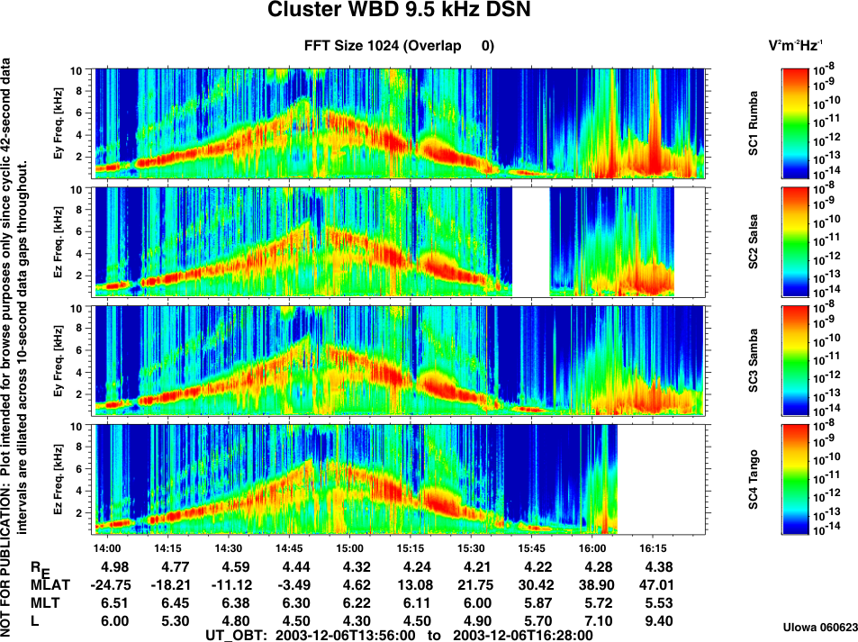

Figure 5.1: Example overview of WBD interval.

Figure 5.1 shows an example of an overview spectrogram of WBD data from a time period when chorus emissions were observed. Panels are included in the overview plots for all of the spacecraft for which WBD data are available at any given time. During the example shown, data were available from spacecraft 1, 2, 3 and 4 for different parts of the plot time interval. The spectrograms are created by 1024 point FFTs and plotted with frequency, in kHz, on the vertical axis, increasing time on the horizontal, and color indicating spectral density, in units of V²m⁻²Hz⁻¹ for the electric field and in relative dB for the magnetic. This example shows the electric field plot from a time period when the WBD receiver switched between the electric and magnetic field antennas, as described above. Text stating that this plot is not suitable for publication due to the mode changes appears on the left hand side. Below the time labels on the horizontal axis, are the ephemeris values applicable to the times marked on the horizontal axis. The ephemeris values are provided for the spacecraft whose data are shown in the bottom panel of the plot, just above the time axis labels (spacecraft 4, in the example shown in Figure 5.1). These ephemeris values are provided only as an indication of the general location of the Cluster quartet within the magnetosphere. Due to varying spacecraft separations, the ephemeris values for the spacecraft shown in the other plot panels may be considerably different from the values given for the spacecraft in the bottom panel. The Cluster spacecraft number and name, by panel, and its respective color bar are shown on the right-hand side of the plot. The total time span of the overview plots depends on the length of the actual WBD operation. If multiple spacecraft are shown in the overview plots, the time span in which WBD data are available for each spacecraft may be different. The plot production date is given in the lower right hand corner.
The WBD overview spectrograms are generated from calibrated Level 1 (L1) data and not from the final CEF/CDF products delivered to the CSA. On rare occasions, when the L1 timing is incorrect or the data is otherwise problematic and cannot be delivered to the CSA as a calibrated waveform, the archive may contain overview plots for time intervals when CEF/CDF waveform products are not available. Furthermore, the calibrated waveforms in CEF/CDF files are not provided for 1-bit data.

5.3 High-Resolution Spectrograms
The high resolution 30-second and 10-minute spectrograms, in gif format, contain full resolution data with no averaging. The spectrograms are created by 1024-point FFTs with frequency on the vertical axis, increasing time on the horizontal, and color indicating spectral density, in dB. Above the spectrogram is a line plot panel, followed by four status lines. The line plot panel at the top provides the gain state (0 to 75 dB, in 5 dB steps) of the instrument. The four status lines provide the following information according to the color code in the upper right corner:
- Data mode - whether real-time data from DSN or Panska Ves, or from the digitally-filtered (Filter) and/or duty-cycled (DC) BM2 mode.
- Antenna - the electric field (Ey or Ez) or the magnetic field (Bx or By) antenna used.
- Resolution - the data digitization level, which can be 1 bit, 4 bit or 8 bit.
- Translation - the translation from base frequency of 0 kHz.

Instead of using the precise conversion frequencies shown in Table 2.3, the translations from the base frequency given in the key on the 30-second and 10-minute spectrograms have been rounded to 125, 250, and 500 kHz. In the lower right-hand corner are the ephemeris values (same as those contained at the bottom of the overview plots discussed above) applicable to the start time of the plot. At the middle right-hand side are given the date and start time of the plot, as well as the spacecraft number.

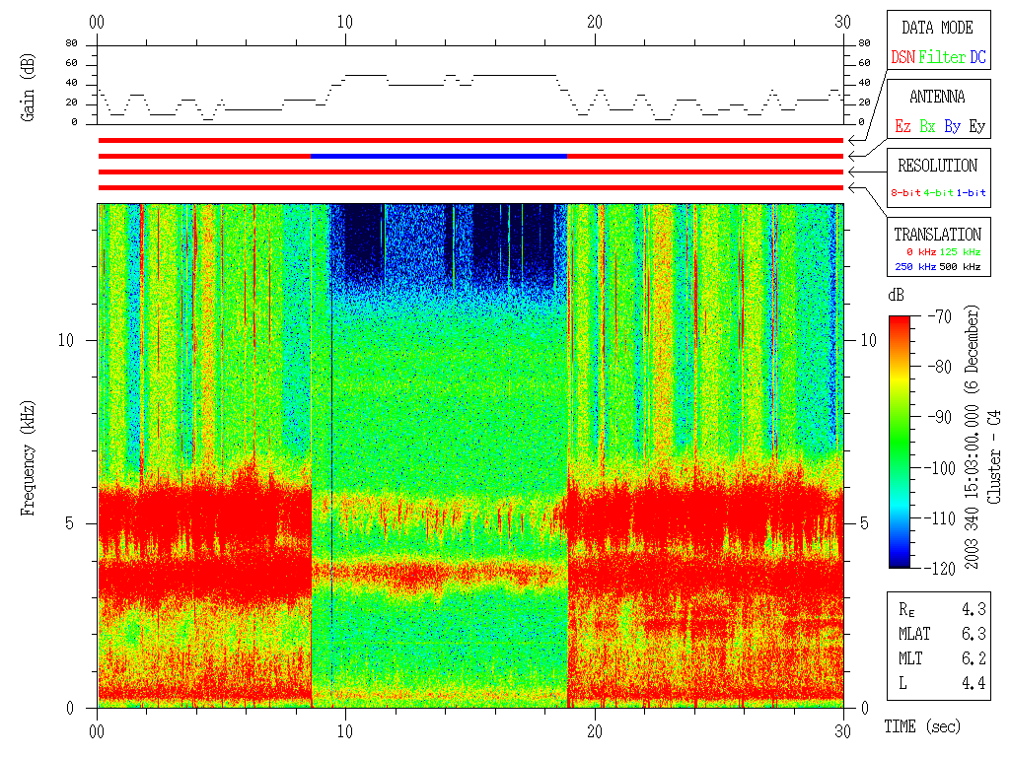
Figure 5.2: Example of the high resolution gif spectrogram plots each covering 30 s intervals.

The 30-second and 10-minute plots contain data from only one spacecraft. If more than one spacecraft was transmitting WBD data at any one time, there will be a separate set of 30-second and 10-minute plots for each spacecraft. An example of the 30 s duration high resolution spectrogram plots from the WBD instrument is shown in Figure 5.2. This example shows an Electric/Magnetic antenna cycling case.

For the same reason as described in Section 5.2 above, the high-resolution gif plots may sometimes be available for time intervals when there are data gaps in CEF/CDF waveform data. This is due to the waveform data being removed during calibration and validation due to various issues.

5.4 High-Resolution Waveform Data

5.4.1 Description of WBD CEF files
The WBD digital Cluster Exchange Format (CEF) files contain two types of data. The first are the global attributes which provide all of the usual information about when the file was produced, general information about the WBD investigation and data, which Cluster spacecraft has provided the data, etc. The second type are the variables consisting of time tags (Epoch), WBD status parameters, time series of calibrated electric or magnetic field amplitudes, angles for orienting the measurement into two reference frames, the DC Offset used in carrying out the calibration, and a data quality flag. An excerpt from a WBD CEF data file is shown below:

Epoch, Bandwidth, Translation, Resolution, ANTENNA, Gain, Ant_B_Field_Angle, Ant_Xgse_Angle, Ant_YZgse_Plane_Angle, DC_Offset, WBD_Elec, WBD_Mag, DATA_QUALITY

2001-04-15T18:30:00.000.024.441.888z, 9.5, 0.0, 8, 0, 75, 25.7, 87.2, 184.5, 127.54, -1.2267e-03, -1.0000e+31, 0
2001-04-15T18:30:00.000.060.880.993z, 9.5, 0.0, 8, 0, 75, 25.7, 87.2, 184.5, 127.54, -1.8255e-03, -1.0000e+31, 0
2001-04-15T18:30:00.000.097.320.097z, 9.5, 0.0, 8, 0, 75, 25.7, 87.2, 184.5, 127.54, -1.2267e-03, -1.0000e+31, 0
2001-04-15T18:30:00.000.133.759.201z, 9.5, 0.0, 8, 0, 75, 25.7, 87.2, 184.5, 127.54, -1.1723e-03, -1.0000e+31, 0
2001-04-15T18:30:00.000.170.198.306z, 9.5, 0.0, 8, 0, 75, 25.7, 87.2, 184.5, 127.54, -1.3900e-03, -1.0000e+31, 0

The column headings, which are shown separated by commas, are provided for reference here (but not like this in the data files, where a standard CEF format is used) and represent the 13 variables contained in the CEF files. The data shown below the column headings are also separated by commas and associated with the column headings. These variables are as follows:

- Epoch: This is the time tag to picoseconds of each data point, given as an Epoch-16 variable. Note that the accuracy of the WBD time tags is on the order of 50 microseconds, but stored to the picosecond per the CDF Epoch-16 variable.
- Bandwidth: Three possible values, in kHz. See section 2 and Tables 2.2 and 2.4.
- Translation: Four possible values, in kHz. See section 2 and Table 2.3.
- Resolution: 3 possible values, in bits/sample. See section 2 and Table 2.4.
- Antenna: 4 possible values (0 through 3). See section 2 and Table 2.1.
- Gain: 16 possible values, used in calibrating the data, in dB. See section 2.
- Ant_B_Field_Angle: Orientation of active antenna (variable 5) to ambient magnetic field, in degrees ranging from 0 to 180. i.e., total angle between antenna used for WBD measurement (variable 5) and FGM-measured B field direction. See Figure 5.3.
- Ant_Xgse_Angle: Orientation of active antenna (variable 5) within a geocentric coordinate system, specifically the total angle between antenna used for WBD measurement (variable 5) and the spacecraft Xgse axis in degrees ranging from 0 to 180. See Figure 5.3.
- Ant_YZgse_Plane_Angle: Orientation of active antenna (variable 5) within a geocentric coordinate system, specifically the total angle between the spacecraft Ygse axis and the projection of the antenna direction (variable 5) in the Ygse-Zgse plane in degrees ranging from 0 to 360. See Figure 5.3.
- DC_Offset: the average value of the zero point of the electric or magnetic field in each 1090 point sample (see WBD ICD), provided as a floating point number (should be close to 127 in normal 8 bit mode since raw data values range from 0 to 255). This number is used in calibrating the data to remove residual DC field effects, and can be used to convert calibrated data points back to original raw data values of 0 to 255 (see WBD Calibration Report).
- WBD_Elec: This is the calibrated value of the electric field, in mV/m. Note that if an electric antenna is active (variable 5), there were will be a fill value for the calibrated magnetic field (variable 12) since WBD samples only one antenna at any one time.
- WBD_Mag: This is the calibrated value of the magnetic field, in nT. Note that if a magnetic antenna is active (variable 5), there were will be a fill value for the calibrated electric field (variable 11) since WBD samples only one antenna at any one time.
- DATA_QUALITY: three possible values: 0 (data ok), 1 (data clipped or questionable), 2 (bad data value). A clipped data point is one in which the measurement was equal to raw data value maximum (255) or minimum (0). This does not necessarily mean the receiver was saturated, but the user should use caution. A bad data value means it was possible to determine through known receiver and data handler behavior that a data point was corrupted. In this case the data value will contain fill.

The above CEF excerpt is thus from 15 April 2001, starting at UT 18:30:00.000024441888. The WBD mode is bandwidth 9.5 kHz, translation of 0 kHz, 8 bits, Ez antenna (value of 0). The gain was 75 dB, which meant that only weak emissions were being detected since 75 dB of gain was being added to the system. The electric field for the first data point was -0.0012267 mV/m and the data quality was good. The three measured angles for this data point were 25.7, 87.2 and 184.5 degrees corresponding to variables 7, 8 and 9, respectively. The DC offset was 127.54.

The data came from Cluster spacecraft 1, as would be apparent from the file name from which the data were taken, as well as information contained in the global attributes contained at the beginning of the file.

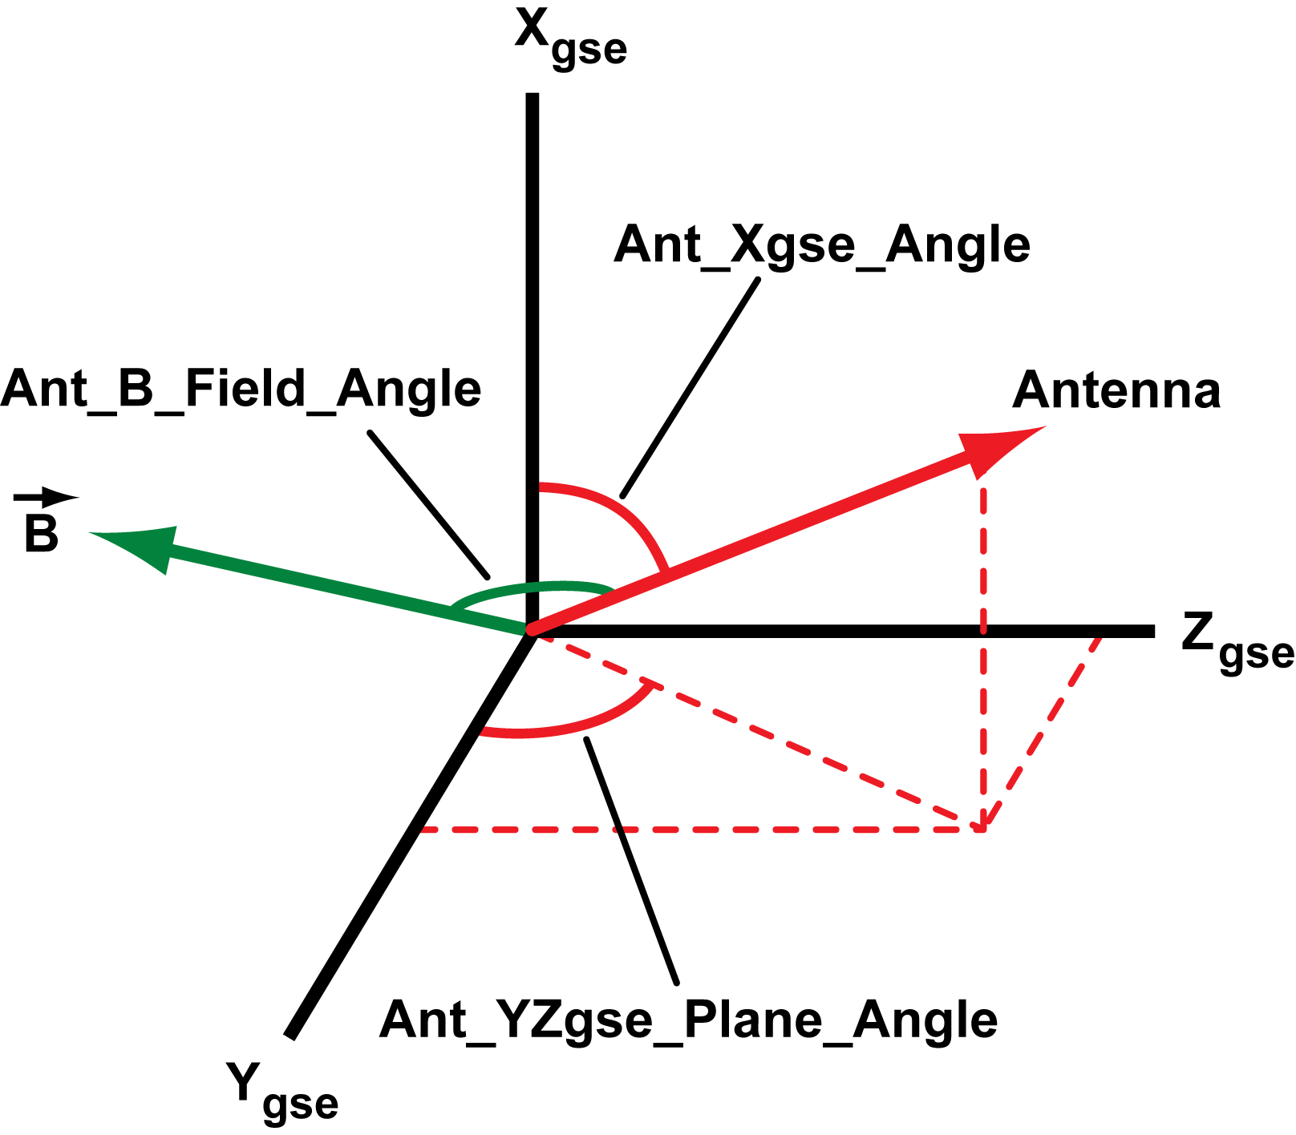
Figure 5.3: Orientation angles related to the WBD measurements (see variables 7-9 above)

5.4.2 WBD CEF versus CDF files
The WBD CEF files are generated at the CAA by converting the original CDF (Common Data Format) files submitted to the CSA by The University of Iowa WBD team and since 2015 by IAP Prague and University of Sheffield. These CDF files, which are also archived at NASA’s CDAWeb (http://cdaweb.gsfc.nasa.gov) are also available for download from the CSA, and have the same format as described above. The information in the files should be identical, but the CDF files are the source dataset, produced and validated by the WBD team.

5.4.2 Level 1 data files
The processing of the WBD waveform data starts by conversion of the raw telemetry packets to Level 1 (L1) files – binary files containing the waveform data in original engineering units (E/B is encoded as an integer) with the time axis being resolved for both the on-board time and ground reference time. This dataset is the source for generation of the CDF/CEF files and also the archived spectrogram plots.

The L1 files are delivered to the CSA, including documentation, but are not meant for routine science use – a significant effort and understanding of various issues is required to process those. They however represent the most complete dataset and may sometimes contain data for intervals which could not be converted to CDF (typically data with timing issues, early commissioning data from 2000 or 1-bit operations).

6 Recommendations

The WBD data product is straightforward in that there is simply a time series of very high time resolution electric or magnetic field values in a specified frequency band. The time series may or may not be continuous and the data are present for only about 4% of any one orbit. The user is recommended to:
- Use the coverage and science summary files to identify times when WBD data are available in the region of interest and the WBD mode is the correct one for the study
- Use the pre-generated overview spectrograms to see if there are waves of interest in these regions of interest
- Use the pre-generated 30 second spectrograms to help determine if the waves are the ones of interest by looking at their fine structure
- Download the 10 minute CEF files, or smaller time intervals, for the periods of interest and check to see if the data are continuous (see table 2.4) as analyzing the data with FFTs, for example, will require adjustments in the maximum length of the FFT sample if the data are not continuous
- Consult the WBD Calibration, Interpretation Issues, and Caveats documents available on both the CSA website and on the Cluster WBD website at Iowa (see Reference 1 below for hyperlink) to ensure against misinterpretation of known problems or interferences in the time and frequency domains and guard against misuse of the data in any way
- Contact the WBD team at The University of Iowa or Institute of Atmospheric Physics as shown on the title page if there are further questions.

7 References

Additional sources of information on the Cluster Wideband Data Plasma Wave Receiver instrument and investigation are as follows:
1. Information about the WBD instrument, a list of data received, survey plots, plotting tools, and a full list of publications using data from the WBD instrument, can be found on the home page of the Cluster Wideband Data Investigation on the World Wide Web: https://space.physics.uiowa.edu/cluster/
2. “Cluster Wideband Data Products in the Cluster Active Archive”, J. S. Pickett, J. M. Seeberger, I. W. Christopher, O. Santolik and K. M. Sigsbee, in The Cluster Active Archive, Harri Laakso, Matthew Taylor and C. Philippe Escoubet, Eds., Springer, 169, 2010.
3. "The Wideband Plasma Wave Investigation," D. A. Gurnett, R. L. Huff, and D. L. Kirchner, Space Science Reviews, 79, pp. 192-208,1997.
4. "First results from the Cluster Wideband Plasma Wave Investigation,” D. A. Gurnett, R. L. Huff, J. S. Pickett, A. M. Persoon, R. L. Mutel, I. W. Christopher, C. A. Kletzing, U. S. Inan, W. M. Martin, J. Bougeret, H. St. C. Alleyne, and K. H. Yearby, Ann. Geophysicae, 19, 1259, 2001.
5. "An investigation into instrumental nonlinear effects,” S. N. Walker, M. A. Balikhin, I. Bates, and R. L. Huff, Adv. Space Res., 30, 2815, 2002.
6. “Characteristics of Langmuir Electric Field Waveforms and Power Spectra Exhibiting Nonlinear Behavior in Earth's Foreshock”, K. Sigsbee, C. A. Kletzing, J. S. Pickett, D. A. Gurnett, S. J. Schwartz, B. Lefebvre, E. Lucek, A. N. Fazakerley, and H. Kucharek, J. Geophys. Res., 115, A10251, doi:10.1029/2009JA014948, Oct. 29, 2010.
7. “Modeling of Cluster’s electric antennas in space: Application to plasma diagnostics,” C. Béghin, P. M. E. Décréau, J. Pickett, D. Sundkvist, and B. Lefebvre, Radio Science, 40, RS6008, doi:10.1029/2005RS003264, 2005.
8. “WBD Response to Bipolar and Tripolar Pulses: Bench Tests vs. in Flight Observations, J. M. Swanner, J. S. Pickett, J. R. Phillips, and D. A. Kirchner, Internal Report and Jessica M. Swanner B.S. Thesis, Department of Physics and Astronomy, The University of Iowa, Iowa City, Iowa, USA, May, 2006 (https://space.physics.uiowa.edu/cluster/https://space.physics.uiowa.edu/cluster/pulse_tests.pdfpulse_tests.pdf)
9. “The Digital Wave Processing Experiment on Cluster,” L. J. C. Woolliscroft, H. Alleyne, C. M. Dunford, A. Sumner, J. A. Thompson, S. N. Walker, K. H. Yearby, A. Buckley, S. Chapman, and M. P. Gough, Space Sci. Rev., 79, 209, 1997.
10. “The wave experiment consortium (WEC),” A. Pedersen, N. Cornilleau-Wehrlin, B. De la Porte, A. Roux, A. Bouabdellah, P. M. E. Decreau, F. Lefeuvre, F. X. Sene, D. Gurnett, R. Huff, G. Gustafsson, G. Holmgren, L. Woolliscroft, H. S. Alleyne, J. A. Thompson, P. H. N. Davies, Space Sci. Rev., 79, 93-105, 1997.
11. “Interpretation of Cluster WBD Frequency Conversion Mode Data”, J. S. Pickett, I. W. Christopher, and D. L. Kirchner, Geosci. Instrum. Method. Data Syst., 3, 21, doi:10.5194/gi-3-21-2014, February 13, 2014.

8 Appendix 1: Special science operations

In this section are listed some of the special science operations campaigns run over the course of the mission.

8.1 WBD/WHISPER/PEACE non-thermal continuum operations

Date  (mm-dd-yyyy) | DOY | Times | WBD 77 kHz SC number | DSN Station | Magnetic latitude range | MLT range | Altitude  range (RE) | Dipole L Value range
10-26-2005 | 299 | 1535-1645 | 4 | 16 | -18.8 to +10.6 | 09:40-09:08 | 5.5-4.7 | 6.2-4.9
11-07-2005 | 311 | 1328-1431 | 4 | 16 | -12.7 to +16.4 | 08:36-08:26 | 5.3-4.6 | 5.6-4.9
11-21-2005 | 325 | 1844-1940 | 2 | 46 | -1.6 to +28.1 | 07:15-06:51 | 4.5-4.4 | 5.7-4.5
12-27-2005 | 361 | 1030-1156 | 2 | 27 | -14.7 to +30.4 | 05:07-04:49 | 5.0-4.4 | 5.9-4.6
12-27-2005 | 361 | 1229-1510 | 4 | 27 | -19.8 to +57.1 | 05:22-03:45 | 5.4-4.4 | 15.5-4.7
01-03-2006 | 3 | 1614-1646 | 4 | 46 | -16.8 to -2.5 | 04:37-04:23 | 5.0-4.6 | 5.4-4.6
01-10-2006 | 10 | 1814-1907 | 1 | 45 | -12.7 to +16.3 | 04:07-03:44 | 4.6-4.3 | 4.8-4.4
01-10-2006 | 10 | 1814-1843 | 2 | 43 | +0.6 to +17.2 | 03:38-03:30 | 4.4-4.3 | 4.4-4.8
01-22-2006 | 22 | 1524-1641 | 1 | 46 | -19.2 to +19.7 | 03:37-02:54 | 4.8-4.3 | 5.4-4.4
01-22-2006 | 22 | 1504-1616 | 2 | 45 | -18.8 to +18.6 | 03:12-02:41 | 4.8-4.3 | 5.3-4.4
01-22-2006 | 22 | 1714-1816 | 4 | 46 | -16.2 to +16.5 | 03:08-02:47 | 4.8-4.4 | 5.2-4.4
02-20-2006 | 51 | 0614-0701 | 4 | 27 | -5.7 to +18.7 | 01:14-01:10 | 4.9-4.4 | 5.0-4.7
03-08-2006 | 67 | 2211-2301 | 4 | 66 | -12.1 to +18.3 | 23:57-00:13 | 4.7-4.3 | 4.9-4.4
03-13-2006 | 72 | 1629-1701 | 4 | 46 | -17.8 to +0.2 | 23:50-23:47 | 4.6-4.3 | 5.1-4.3
03-25-2006 | 84 | 1354-1449 | 4 | 46 | -18.8 to +12.0 | 23:10-22:55 | 4.7-4.2 | 5.2-4.3
05-05-2006 | 125 | 0045-0106 | 4 | 27 | +5.2 to +18.0 | 20:45-20:43 | 4.4-4.2 | 4.4-4.6
05-16-2006 | 136 | 2135-2235 | 4 | 54 | -16.3 to +18.9 | 19:58-20:07 | 4.9-4.1 | 5.3-4.4
05-26-2006 | 146 | 0930-1016 | 1 | 34 | -13.8 to +14.6 | 19:19-18:56 | 4.3-4.0 | 4.5-4.1
06-26-2006 | 177 | 0750-0826 | 1 | 46 | +0.07 to +23.7 | 17:04-16:46 | 4.1-4.0 | 4.0-4.7

8.2 WBD/PEACE Chorus operations
DOY | Date | Time Period | WBD SC | Magnetic latitude | MLT range | Altitude range (RE) | Dipole L value  range | Chorus  observed ? | PEACE SC | WBD Notes
181 | 2003-06-30 | 06:03-07:00 | 134 | -23.9 to +28.4 | 16:28-16:05 (-) | 4.7-4.4 | 4.4-5.9 | Yes | 24 | SC1: 06:16-06:55, SC3: 06:30-06:55
185 | 2003-07-04 | 23:45-02:56 | 1234 | -22.7 to +68.5 | 16:29-14:35 (-) | 5.2-4.4 | 38.6-4.5 | ? | 134 | SC1 ends 02:25, SC2 ends 02:26,  SC3 ends at 02:53
197 | 2003-07-16 | 21:28-23:32 | 234 | -11.3 to +55.8 | 15:33-14:50 (-) | 4.8-4.4 | 14.9-4.6 | ? | 1234
200 | 2003-07-19 | 06:58-07:35 | 14 | -19.0 to +4.4 | 15:01-14:57 (-) | 4.6-4.4 | 5.1-4.4 | Yes | 1234
205 | 2003-07-24 | 00:48-03:00 | 1234 | -16.2 to +50.9 | 15:08-14:08 (-) | 4.8-4.4 | 12.8-4.5 | Yes | 1234 | SC1 ends at 01:45
219 | 2003-08-07 | 05:44-08:03 | 234 | -65.8 to -3.5 | 14:03-13:44 (-) | 6.1-4.4 | 36.3-4.5 | ? | 12, partial on 34 | SC2 and SC33 end at 07:55
223 | 2003-08-11 | 23:59-02:55 | 234 | -51.7 to +26.3 | 14:31-13:21 (-) | 6.0-4.4 | 15.7-4.4 | No | 1234
228 | 2003-08-16 | 19:51-21:30 | 1234 | -4.0 to +51.2 | 13:26-12:51 (-) | 4.7-4.4 | 4.6-11.7 | Probably not | 1234 | SC4 ends at 21:15
231 | 2003-08-19 | 03:50-05:45 | 234 | -50.5 to +5.8 | 13:30-13:05 (-) | 5.5-4.4 | 14.1-4.4 | Yes | 1234
235 | 2003-08-23 | 21:00-23:50 | 1234 | -54.1 to +14.2 | 13:39-12:46 (-) | 6.4-4.4 | 18.8-4.5 | Yes | partial 1234
243 | 2003-08-31 | 00:58-03:40 | 1234 | -53.0 to +22.4 | 13:11-12:18 (-) | 5.8-4.4 | 15.9-4.4 | ? | 1234 | SC1 ends 03:30,  SC2 and SC3 end at 03:35
254 | 2003-09-11 | 21:44-00:40 | 1234 | -58.8 to +12.0 | 12:49-11:33 (-) | 6.5-4.4 | 24.2-4.4 | Yes | 1234 | SC3 ends 23:31
259 | 2003-09-16 | 17:32-19:39 | 1234 | -17.1 to +52.1 | 11:29-10:49 (-) | 4.9-4.4 | 12.1-4.5 | Yes | 124, partial on 3 | SC3ends at 18:12
262 | 2003-09-19 | 00:58-03:47 | 1234 | -68.4 to +3.6 | 12:18-11:14 (-) | 6.5-4.4 | 47.9-4.4 | Yes | 1234 | SC3 ends at 02:46
273 | 2003-09-30 | 22:25-01:30 | 1234 | -64.0 to +14.5 | 11:43-10:24 (-) | 6.5-4.3 | 33.8-4.3 | ? | 124, partial on 3 | SC3 ends at 00:15
278 | 2003-10-05 | 16:34-20:36 | 1234 | -52.7 to +55.8 | 10:35-09:17 (-) | 6.5-4.3 | 17.6-4.4 | Yes | partial 1234
285 | 2003-10-12 | 19:52-22:50 | 1234 | -58.7 to +13.8 | 10:50-09:34 (-) | 6.5-4.3 | 24.8-4.3 | No | 124, partial on 3 | SC4 ends at 22:05
290 | 2003-10-17 | 15:33-17:43 | 23 | -18.5 to +51.3 | 09:36-08:53 (-) | 5.0-4.3 | 11.7-4.5 | Yes | 2, partial on 134
304 | 2003-10-31 | 20:25-23:29 | 1234 | -64.8 to +14.1 | 09:43-08:22 (-) | 6.5-4.3 | 35.7-4.3 | Yes | 1234 | SC4 ends at 22:45
309 | 2003-11-05 | 16:03-18:37 | 1234 | -25.4 to +55.4 | 08:32-07:20 (-) | 5.1-4.3 | 14.3-4.4 | Yes | 23,partial 14 | SC3 ends at 16:51;  SC4 starts at 17:40
316 | 2003-11-12 | 17:58-20:54 | 234 | -58.0 to +18.5 | 08:44-07:29 (-) | 6.3-4.2 | 22.4-4.3 | Yes | 1234 | SC3 ends at 19:42
321 | 2003-11-17 | 13:38-15:38 | 1234 | -16.4 to +51.9 | 07:41-06:57 (-) | 4.8-4.2 | 11.6-4.4 | Yes | 1234
335 | 2003-12-01 | 18:22-20:45 | 1234 | -65.3 to -9.7 | 07:38-06:19 (-) | 6.5-4.4 | 37.2-4.5 | No | partial 1234 | SC4 ends at 20:40
340 | 2003-12-06 | 13:56-16:27 | 1234 | -26.5 to +55.3 | 06:31-05:18 (-) | 5.0-4.2 | 14-4.3 | Yes | 1234
347 | 2003-12-13 | 15:40-18:37 | 124 | -60.4 to +13.5 | 06:45-05:23 (-) | 6.5-4.2 | 26.6-4.3 | Yes | 1234 | SC123 start at 16:10
352 | 2003-12-18 | 11:27-13:29 | 1234 | -18.6 to +51.2 | 05:37-04:55 (-) | 4.9-4.2 | 11.2-4.4 | No | partial 1234 | SC3:12:00-12:10
354 | 2003-12-20 | 18:54-21:41 | 124 | -69.7 to +3.2 | 06:02-04:51 (-) | 6.5-4.2 | 53.6-4.2 | Yes | 1234
359 | 2003-12-25 | 14:38-15:45 | 124 | -24.6 to +11.8 | 05:10-04:42 (-) | 4.9-4.2 | 5.8-4.3 | Yes | 124
001 | 2004-01-01 | 16:26-19:19 | 124 | -62.8 to +14.1 | 05:22-04:02 (-) | 6.3-4.2 | 30.1-4.2 | Yes | 1234 | SC4 ends at 18:20
006 | 2004-01-06 | 11:49-14:19 | 1234 | -25.7 to +55.0 | 04:22-03:09 (-) | 5.0-4.2 | 13.8-4.3 | Yes | 124, partial on 3 | SC3:12:42-12:52; SC2 ends at 12:47
013 | 2004-01-13 | 13:48-16:32 | 1234 | -57.6 to +11.7 | 04:32-03:16 (-) | 6.3-4.2 | 21.9-4.3 | Yes | 1234 | SC3: 16:10-16:20
018 | 2004-01-18 | 09:24-11:24 | 1234 | -18.3 to +50.3 | 03:22-02:44 (-) | 4.9-4.2 | 10.7-4.4 | Yes | 1234 | SC3 starts at 10:13 and ends at 10:23
020 | 2004-01-20 | 17:15-19:37 | 1234 | -63.3 to +3.0 | 03:35-02:45 (-) | 6.0-4.2 | 29.7-4.2 | Yes | 1234 | SC3 starts at 19:12 and ends at 19:22
037 | 2004-02-06 | 09:52-12:22 | 1234 | -26.1 to +54.7 | 02:12-00:59 (-) | 5.0-4.2 | 13.4-4.3 | Yes | 1234 | SC3 starts at 10:47 and ends at 10:57
044 | 2004-02-13 | 11:44-14:48 | 1234 | -60.2 to +17.6 | 02:35-01:09 (-) | 6.5-4.2 | 26.3-4.2 | Yes | 1234 | SC3 starts at 14:08 and ends at 14:18
049 | 2004-02-18 | 07:28-09:31 | 1234 | -19.5 to +51.3 | 01:11-00:30 (-) | 4.9-4.2 | 11.1-4.4 | Yes | 1234 | SC3 starts at 08:14 and ends at 08:24
051 | 2004-02-20 | 15:00-17:43 | 1234 | -69.6 to 0.9 | 02:02-00:48 (-) | 6.5-4.2 | 53.2-4.2 | Yes | partial 1234 | SC3 starts at 17:20 and ends at 17:30
056 | 2004-02-25 | 10:55-11:46 | 1234 | -24.0 to +4.1 | 00:56-00:33 (-) | 4.8-4.2 | 5.7-4.2 | Yes | partial 1234 | SC3 starts at 11:34 and ends at 11:44
063 | 2004-03-03 | 13:05-15:26 | 1234 | -56.2 to +12.1 | 00:57-00:00 (-) | 5.8-4.1 | 18.7-4.2 | Yes | 1234 | SC3 starts at 14:47 and ends at 14:57
068 | 2004-03-08 | 08:05-10:33 | 1234 | -26.8 to +54.5 | 00:07-22:53 (-) | 5.0-4.1 | 13.1-4.3 | Yes | 1234 | SC3 starts at 09:00 and ends at 09:10
075 | 2004-03-15 | 11:05-12:55 | 234 | -41.2 to +15.2 | 23:55-23:10 (-) | 5.2-4.1 | 9.2-4.2 | Yes | 1234 | SC3 starts at 12:23 and ends at 12:33
080 | 2004-03-20 | 05:41-07:46 | 1234 | -20.6 to +52.3 | 23:12-22:23 (-) | 4.9-4.1 | 11.4-4.3 | Yes | partial 1234 | SC3 starts at 06:13 and ends at 06:23
082 | 2004-03-22 | 13:15-15:52 | 1234 | -70.2 to -1.6 | 23:57-22:53 (-) | 6.5-4.1 | 56.5-4.1 | No | 1234 | SC3 starts at 15:52 and ends at 15:52
087 | 2004-03-27 | 09:08-11:15 | 234 | -22.7 to +50.3 | 22:55-21:51 (-) | 4.7-4.1 | 10.7-4.2 | Yes | 1234 | SC3 starts at 09:43 and ends at 09:53
099 | 2004-04-08 | 06:40-08:38 | 1234 | -15.6 to +54.4 | 22:03-20:56 (-) | 4.6-4.1 | 12.8-4.2 | Yes | 1234 | SC3: 07:00-07:10 and 08:01-08:10
106 | 2004-04-15 | 10:14-11:00 | 1234 | -14.6 to +16.0 | 21:29-21:10 (-) | 4.3-4.0 | 4.6-4.1 | No | 1234 | SC3: 10:31-10:41
111 | 2004-04-20 | 03:47-05:49 | 1234 | -21.1 to +52.8 | 21:18-20:27 (-) | 4.8-4.0 | 11.4-4.2 | No | 1234 | SC3 starts at 04:18 and ends at 04:28
113 | 2004-04-22 | 11:55-13:52 | 1234 | -61.4 to -2.2 | 21:20-20:53 (-) | 65.7-4.1 | 25.1-4.1 | No | 1234 | SC3 starts at 13:43 and ends at 13:53
118 | 2004-04-27 | 06:40-08:09 | 124 | -35.8 to +11.7 | 21:08-20:29 (-) | 5.1-4.0 | 7.7-4.1 | Yes | 1234 | SC1 and SC2 start at 06:56
134 | 2004-05-13 | 09:44-10:53 | 124 | -35.2 to +16.3 | 19:43-19:23 (-) | 4.9-4.3 | 7.3-4.3 | No | 3, partial on 2
239 | 2004-08-26 | 00:41-01:18 | 2 | -4.0 to +15.7 | 12:51-12:37 (-) | 4.5-4.4 | 4.4-4.7 | ? | 2
250 | 2004-09-06 | 21:20-22:20 | 124 | -22.4 to +11.2 | 12:24-12:01 (-) | 5.0-4.4 | 5.8-4.5 | Yes | 2, partial on 134 | SC1 ends at 22:00, SC4 ends at 22:05
262 | 2004-09-18 | 19:10-21:07 | 24 | -3.9 to +56.7 | 11:26-20:22 (-) | 4.7-4.3 | 15.5-4.5 | Yes | 4, partial on 13
305 | 2004-10-31 | 14:27-16:09 | 124 | -11.8 to +49.9 | 08:50-08:13 (-) | 4.7-4.2 | 10.3-4.4 | Yes | 124
336 | 2004-12-01 | 12:31-13:58 | 124 | -6.9 to +49.0 | 06:51-06:17 (-) | 4.6-4.2 | 9.8-4.4 | Yes | 124, partial on 3
032 | 2005-02-01 | 08:20-09:54 | 1234 | -11.5 to +48.4 | 02:26-01:54 (-) | 4.7-4.1 | 9.7-4.4 | ? | 1234 | SC3 starts at 08:44, ends at 08:54
039 | 2005-02-08 | 11:46-13:36 | 124 | -11.6 to +54.7 | 01:59-00:47 (-) | 4.6-4.1 | 13.4-4.3 | Yes | 124, partial on 3
051 | 2005-02-20 | 08:46-10:50 | 1234 | -20.8 to +53.0 | 01:17-00:09 (-) | 4.8-4.1 | 11.4-4.3 | Yes | 124, partial on 3 | SC3 starts at 09:30, ends at 09:40
058 | 2005-02-27 | 12:10-14:19 | 1234 | -27.2 to +50.2 | 00:53-23:49 (-) | 4.8-4.1 | 10.8-4.2 | Yes | 124, partial on 3 | SC3 starts at 14:05, ends at 14:15
063 | 2005-03-04 | 06:28-08:05 | 12 | -11.9 to +49.2 | 00:18-23:43(-) | 4.6-4.1 | 10.0-4.3 | No | 124
082 | 2005-03-23 | 06:59-08:00 | 124 | -21.0 to +16.6 | 23:16-22:53 (-) | 4.8-4.1 | 5.5-4.2 | Yes | None
089 | 2005-03-30 | 10:25-11:33 | 124 | -25.8 to +18.4 | 22:50-22:18(-) | 4.6-4.0 | 5.7-4.1 | No | 124, partial on 3 | SC2 starts at 10:45
094 | 2005-04-04 | 04:35-06:12 | 1234 | -13.1 to +51.3 | 22:24-21:40 (-) | 4.6-4.0 | 10.0-4.2 | Yes | 124, partial on 3 | SC3 starts at 05:00, ends at 05:10
096 | 2005-04-06 | 13:45-14:35 | 124 | -31.1 to +4.6 | 22:12-22:03 (-) | 4.5-4.0 | 6.2-4.0 | No | 124, partial on 3
101 | 2005-04-11 | 07:55-08:38 | 124 | -19.6 to +9.7 | 22:03-21:42 (-) | 4.5-4.0 | 5.1-4.1 | ? | 124
108 | 2005-04-18 | 09:27-12:10 | 124 | -63.1 to +14.2 | 22:38-21:10 (-) | 6.3-4.0 | 30.9-4.0 | Yes | 1234
113 | 2005-04-23 | 05:16-07:10 | 1234 | -17.1 to +56.8 | 21:18-20:00 (-) | 4.6-3.9 | 13.0-4.1 | Yes | 1234 | SC3: 05:48-05:58 & 06:58-07:08
120 | 2005-04-30 | 08:11-09:12 | 124 | -32.7 to +5.1 | 20:58-20:28 (-) | 4.8-4.0 | 6.7-4.0 | No | 124, partial on 3
132 | 2005-05-12 | 06:00-07:46 | 124 | -15.8 to +54.6 | 20:03-18:49 (-) | 4.3-3.9 | 4.7-4.0 | No | partial on 1234
139 | 2005-05-19 | 08:30-10:07 | 124 | -45.0 to +14.2 | 19:47-19:07 (-) | 5.0-3.9 | 10.1-3.9 | Yes | partial on 1234 | SC1 starts at 08:40
313 | 2005-11-09 | 19:45-20:45 | 1 | -43.8 to -23.9 | 09:17-08:42 (-) | 5.9-5.0 | 11.3-6.0 | No | 34, partial on 12
313 | 2005-11-09 | 19:45-20:45 | 2 | -30.3 to -3.4 | 08:25-08:01 (-) | 5.1-4.5 | 6.9-4.5 | No | 34, partial on 12
313 | 2005-11-09 | 19:45-21:21 | 4 | -69.3 to -54.8 | 10:16-08:57 (-) | 8.2-6.6 | 65.7-19.7 | ? | 34, partial on 12
330 | 2005-11-26 | 12:58-13:50 | 1 | -6.8 to +19.7 | 07:39-07:21 (-) | 4.9-4.5 | 5.0-4.7 | Yes | partial on 124
330 | 2005-11-26 | 12:14-13:05 | 2 | -11.9 to +14.1 | 07:15-07:08 (-) | 4.9-4.5 | 5.2-4.6 | Yes | partial on 124
008 | 2006-01-08 | 08:59-09:26 | 1 | -0.5 to +14.1 | 04:35-04:31 (-) | 4.7-4.5 | 4.7-4.6 | Yes | partial on 1234
008 | 2006-01-08 | 10:29-11:15 | 4 | -4.3 to +18.5 | 04:23-04:10 (-) | 4.9-4.5 | 4.9-4.7 | Yes | partial on 1234
027 | 2006-01-27 | 09:39-10:27 | 1 | -6.4 to +18.8 | 03:18-02:59 (-) | 4.8-4.4 | 4.9-4.6 | Yes | 4, partial on 123
027 | 2006-01-27 | 09:02-09:39 | 2 | -12.9 to +5.4 | 02:53-02:48 (-) | 4.9-4.5 | 5.2-4.6 | Yes | 4, partial on 123
027 | 2006-01-27 | 10:44-13:41 | 4 | -19.1 to +65.6 | 03:11-00:55 (-) | 5.3-4.4 | 4.6-27.8 | Yes | 4, partial on 123
046 | 2006-02-15 | 10:00-10:16 | 2 | -18.4 to -11.3 | 01:43-01:38 (-) | 5.0-4.7 | 5.5-4.9 | Yes | 234, partial on 1
058 | 2006-02-27 | 09:09-11:31 | 4 | -19.3 to +51.2 | 01:06-23:41 (-) | 5.2-4.4 | 11.2-4.6 | No | 4, partial on 123
065 | 2006-03-06 | 11:24-12:23 | 1 | -19.6 to +9.2 | 00:54-00:19 (-) | 4.8-4.3 | 5.5-4.4 | No | 124
065 | 2006-03-06 | 11:24-12:23 | 2 | -13.9 to +17.4 | 00:21-23:54 (-) | 4.6-4.3 | 4.9-4.3 | No | 124
077 | 2006-03-18 | 10:01-11:01 | 2 | +21.3 to +53.8 | 23:07-22:20 (-) | 4.2-4.5 | 4.9-12.9 | No | 4, partial on 3
077 | 2006-03-18 | 10:19-10:46 | 4 | -18.5 to -6.6 | 23:50-23:37 (-) | 4.9-4.6 | 5.5-4.6 | Yes | 4, partial on 3
082 | 2006-03-23 | 04:30-05:26 | 4 | -8.9 to +20.7 | 23:18-23:08 (-) | 4.9-4.3 | 5.0-4.6 | No | 24, partial on 13
108 | 2006-04-18 | 07:59-09:01 | 1 | -2.8 to +32.4 | 21:52-21:06 (-) | 4.4-4.1 | 4.3-5.8 | No | 4, partial on 123
108 | 2006-04-18 | 08:39-09:51 | 4 | -19.2 to +18.6 | 21:51-21:13 (-) | 4.8-4.1 | 5.4-4.3 | No | 4, partial on 123
127 | 2006-05-07 | 08:49-09:35 | 1 | -8.8 to +17.9 | 20:38-20:08 (-) | 4.3-4.1 | 4.5-4.2 | No | partial on 4
151 | 2006-05-31 | 04:50-05:35 | 1 | +44.1 to +66.2 | 18:09-16:33 (-) | 4.1-4.5 | 7.9-27.6 | No | 1234
151 | 2006-05-31 | 04:50-05:35 | 2 | +50.3 to _71.6 | 17:51-16:30 (-) | 4.2-4.7 | 10.2-46.9 | No | 1234
151 | 2006-05-31 | 05:20-05:30 | 3 | +52.8 to +58.3 | 17:42-17:25 (-) | 4.1-4.2 | 11.2-15.1 | No | 1234
151 | 2006-05-31 | 04:50-06:00 | 4 | -13.1 to +26.5 | 19:05-18:22 (-) | 4.6-4.0 | 5.0-4.2 | Yes | 1234
163 | 2006-06-12 | 01:25-01:40 | 1 | +22.3 to +31.9 | 18:16-18:04(-) | 4.0-4.0 | 4.7-5.5 | No | 134, partial on 2
163 | 2006-06-12 | 01:25-01:40 | 2 | +34.6 to +44.2 | 18:04-17:37(-) | 4.0-4.1 | 5.9-7.9 | No | 134, partial on 2 | SC2 ends at 01:37
163 | 2006-06-12 | 01:25-01:35 | 3 | +2.0 to +7.7 | 18:17-18:13(-) | 4.3-4.2 | 4.3-4.3 | Yes | 134, partial on 2
196 | 2006-07-15 | 07:45-08:34 | 1 | -32.4 to -4.2 | 16:11-15:49(-) | 4.6-4.1 | 6.5-4.1 | Yes | 124
196 | 2006-07-15 | 07:45-08:34 | 2 | -21.6 to +9.8 | 15:34-15:27(-) | 4.3-4.0 | 5.0-4.0 | Yes | 124
196 | 2006-07-15 | 07:45-08:34 | 4 | -74.4 to -63.5 | 16:59-16:03(-) | 7.2-6.2 | 98.9-31.3 | No | 124

8.3 Other special operations

8.3.1 HAARP OPERATIONS

Date DOY Start Time End Time WBD ON DSN Station

08/13/01 225 23:43 00:53 CLU1 DSS-27
225 23:10 00:59 CLU3 DSS-16

11/26/01 330 15:46 18:24 CLU3 DSS-15

06/12/02 163 00:55 02:53 CLU1 DSS-24
163 00:55 02:53 CLU2 DSS-16
163 00:55 02:53 CLU3 DSS-27
163 00:55 02:53 CLU4 DSS-16

11/09/02 313 05:15 08:25 CLU3 DSS-27
313 05:00 08:25 CLU4 DSS-15

01/26/03 026 12:00 14:00 CLU2 DSS-24
026 12:00 12:30 CLU1 DSS-16
026 12:00 14:00 CLU4 DSS-27

02/07/03 038 11:00 12:00 CLU4 DSS-16
038 11:00 12:00 CLU3 DSS-27

02/21/03 052 22:00 00:27 CLU4 DSS-16

02/26/03 057 10:05 12:00 CLU1 DSS-27
057 10:05 12:00 CLU2 DSS-16

03/10/03 069 09:00 10:00 CLU1 DSS-27
069 09:00 10:00 CLU2 DSS-16

03/11/03 131 05:30 07:00 CLU3 DSS-27
131 05:30 07:00 CLU4 DSS-16

06/11/03 162 03:30 05:00 CLU1 DSS-27
162 03:30 05:00 CLU4 DSS-16
162 04:30 05:00 CLU2 DSS-24

06/23/03 174 02:30 02:46 CLU1 DSS-24
174 02:30 05:00 CLU2 DSS-15
174 02:30 03:20 CLU3 DSS-27
174 02:30 05:00 CLU4 DSS-16

07/04/03 185 23:42 02:25(5th) CLU1 DSS-14
185 23:42 02:26(5th) CLU2 DSS-27
185 23:42 02:53(5th) CLU3 DSS-15
185 23:42 02:56(5th) CLU4 DSS-16

07/24/03 185 00:45 01:45 CLU1 DSS-34
185 00:45 03:00 CLU2 DSS-16
185 00:45 03:00 CLU3 DSS-15
185 00:45 03:00 CLU4 DSS-27

11/05/03 309 17:30 18:30 CLU1 DSS-15
309 17:30 18:30 CLU2 DSS-16
309 17:39 18:30 CLU4 DSS-27

12/06/03 340 15:30 16:27 CLU1 DSS-24
340 15:30 16:19 CLU2 DSS-14
340 15:30 16:27 CLU3 DSS-16
340 15:30 16:06 CLU4 DSS-27

01/06/04 006 13:10 14:15 CLU1 DSS-27
006 13:10 14:15 CLU4 DSS-24

02/06/04 037 11:20 12:20 CLU1 DSS-27
037 11:20 12:20 CLU2 DSS-15
037 11:20 12:16 CLU4 DSS-14

03/08/04 068 09:30 10:25 CLU1 DSS-14
068 09:30 10:30 CLU2 DSS-15
068 09:30 10:30 CLU4 DSS-27

03/27/04 087 10:00 11:00 CLU2 DSS-16
087 10:00 11:00 CLU4 DSS-14

04/08/04 099 07:40 08:29 CLU1 DSS-14
099 07:40 08:38 CLU2 DSS-15
099 08:00 08:10 CLU3 DSS-16
099 07:40 08:38 CLU4 DSS-27

01/08/05 008 14:50 15:20 CLU1 DSS-24
008 14:30 15:20 CLU2 DSS-15
008 14:30 15:20 CLU4 DSS-16

01/20/05 020 12:01 13:00 CLU1 DSS-16
020 12:05 13:23 CLU4 DSS-24

02/08/05 039 11:46 13:36 CLU1 DSS-15
039 11:46 13:36 CLU2 DSS-27
039 11:46 13:36 CLU4 DSS-24

02/20/05 051 08:46 10:50 CLU1 DSS-15
051 08:49 10:50 CLU2 DSS-27
051 08:46 10:50 CLU4 DSS-16

04/23/05 113 05:36 07:10 CLU1 DSS-16
113 05:36 07:10 CLU2 DSS-15
113 05:16 07:10 CLU4 DSS-24

8.3.2 IMAGE/RPI OPERATIONS

Date DOY Start Time End Time WBD ON DSN Station

04/23/02 113 04:15 05:15 CLU1 DSS-15
113 04:15 05:15 CLU2 DSS-16
113 04:15 05:15 CLU3 DSS-27
113 04:15 05:15 CLU4 DSS-24

10/23/02 296 11:00 11:30 CLU2 DSS-16
296 11:00 11:30 CLU3 DSS-15
296 11:00 11:30 CLU4 DSS-27

05/27/03 147 22:01 23:14 CLU1 DSS-27
147 22:06 23:14 CLU2 DSS-24
147 22:06 23:14 CLU3 DSS-14
147 22:06 23:14 CLU4 DSS-15

05/30/03 150 07:08 08:20 CLU1 DSS-14
150 07:08 08:20 CLU2 DSS-27
150 07:08 08:20 CLU3 DSS-15
150 07:08 08:20 CLU4 DSS-24

09/18/05 261 06:45 08:45 CLU1 DSS-45
261 06:45 08:45 CLU4 DSS-46

09/25/05 268 07:00 09:50 CLU2 DSS-45
268 07:00 09:50 CLU4 DSS-46

8.3.3 WHISPER MUTUAL IMPEDANCE TEST

Date DOY Start Time End Time WBD ON DSN Station

04/11/04 102 00:42 00:57 CLU1 DSS-45
102 00:42 00:57 CLU2 DSS-46
102 00:42 00:57 CLU4 DSS-34

05/14/04 135 22:10 22:25 CLU1 DSS-34
135 22:10 22:25 CLU4 DSS-45

9 Appendix 2: Interpretation issues

The following text is based on the html document published on the WBD website at https://space.physics.uiowa.edu/plasma-wave/cluster/ .http://www-pw.physics.uiowa.edu/cluster/

CLUSTER WBD INTERPRETATION ISSUES
In certain regions of the orbit and during certain planned operations, interference from other instruments and/or spacecraft systems affects the WBD measurements. At these times one must use caution so as not to misinterpret the WBD data. In addition, certain design features of the WBD hardware and software and of the electric antenna that is used by WBD make the WBD instrument 1) vulnerable to nonlinear effects in the form of harmonic generation under certain environmental conditions and 2) susceptible to distorting waveforms when measuring specific types of waves, most notably solitary waves in the form of pulses. In these cases, extreme caution must be used when analyzing the data. The remainder of this page will be devoted to a description of the various known interferences and instrumental effects with examples of how they are manifested in the WBD data. For information on known problems with the WBD data set, the user is referred to the WBD Caveats document, which is available on the WBD website (https://space.physics.uiowa.edu/plasma-wave/cluster/http://www-pw.physics.uiowa.edu/cluster/) and at the Cluster Science Archive (CSA) (https://chttps://csa.esac.esa.int/sa.eshttps://csa.esac.esa.int/ac.esa.inthttps://csa.esac.esa.int/). If you need further information on those problems, or the interpretation issues discussed below, please contact Jolene Pickett, Principal Investigator, at: pickett@uiowa.edu.

Electron Drift Instrument (EDI)
The purpose of the Electron Drift Instrument (EDI) is to measure the strength of electric and magnetic fields in the vicinity of the Cluster spacecraft. This is done by firing two weak beams of electrons into the space around each spacecraft and receiving them on the opposite side of the spacecraft from which each was fired. Figures 1 and 2 below show how active operation of EDI affects WBD measurements. Both of these calibrated spectrograms reveal EDI's operation as horizontal lines of interference. On this date EDI was running in high current mode, making it easily detectable by the electric antennas. Figure 1 shows what EDI's interference looks like on a half hour time scale. When viewed on a smaller time scale, it becomes apparent that the signals produced by EDI pulsate in intensity as is clearly shown in Figure 2. This periodicity in the intensity is due to the Windshield-Wiper (WW) Mode EDI was running this day. In the WW-mode EDI sweeps its two weak beams of electrons rapidly back and forth through a range of angles; hence the name 'windshield-wiper'. Over time the paths the two beams of electrons take around the spacecraft change due to the different angles they are swept through upon leaving the spacecraft by EDI's two electron guns. This propagation in the paths that the electron beams take is detected by the electric antennas as varying intensities in the electric field. Interference from EDI on spacecraft 4 will never be seen because this instrument was never operational, and spacecraft 2 produces unusually intense interference due to a malfunction. Starting January 24, 2010, the EDI team decided not to operate EDI in this active mode on any spacecraft during WBD operations, so EDI interference is not expected after that date but might be present infrequently for specially planned operations or through faulty commanding.
Figures 1 and 2 also show a more constant line of intensity at roughly 65.75 kHz. This is the fundamental mode created by the interference associated with the electrical circuits of the spacecrafts' batteries (see discussion of this in the section below entitled "Spacecraft Battery Interference").
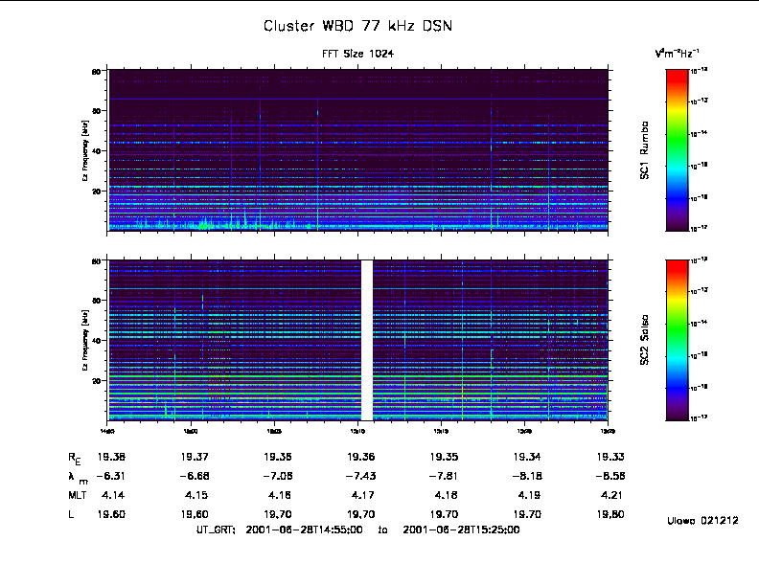
Figure 1
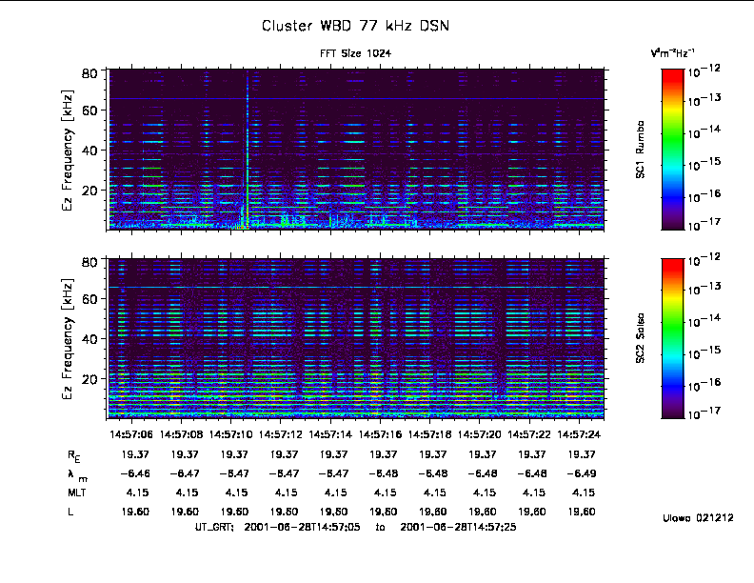
Figure 2

Receiver Gain Effects for Wide Band Data Instrument (WBD)
In November of 2002 it was discovered that automatic gain changes in the WBD receiver were causing impulses to be seen in electric and magnetic field data. Figure 3 shows what these impulses look like in a line plot of the raw count data versus time and Figure 4 is a calibrated spectrogram for the same time period. Examination of Figure 3 shows that there are two kinds of impulses. The first of these two (e.g., at ~ 0.55 seconds after start in panel 1 of Figure 3) causes the data to spike and clip in the positive direction (a raw count of 255). The other impulse (eg., at ~ 1.18 seconds after start in panel 1 of Figure 3) is a reflection of the first about the horizontal axis. Thus this one clips in the negative direction (a raw count of 0). Only specific changes in the receiver's gain cause these two impulses. The positively clipped impulse is only seen when the gain is changed from 35 dB to 40 dB and 50 dB to 45 dB. The negatively clipped impulse is seen at a gain change from 45 dB to 50 dB. These are the only times such impulses are seen, and, when such gain changes are made, these impulses will always be present in the data. The time it takes these impulses to damp out is roughly one tenth of a second.
Correlations between Figures 3 and 4 are easily seen thus identifying the impulses in a spectrogram. The line plot for spacecraft 1 reveals a positively clipped impulse occurring at approximately 9:29:19.55 and a negatively clipped impulse developing just before 9:29:20.20. Inspection of Figure 4 for spacecraft 1 at these same times shows a disturbance in the spectrogram being one pixel wide that covers the entire bandwidth. The disturbances appear as thin columns that start out red (greatest intensity) at the base frequency and span the visible spectrum to green towards the upper bound of the bandwidth. Similar correlations amongst Figure 3 and Figure 4 can be made for spacecrafts 2, 3 and 4.
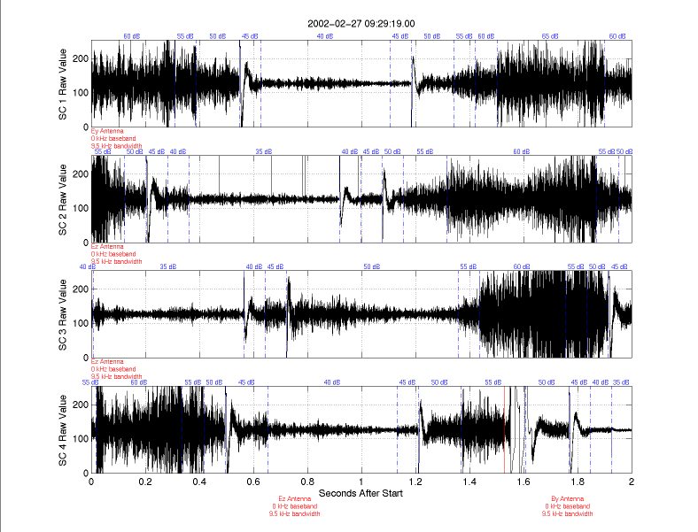
Figure 3
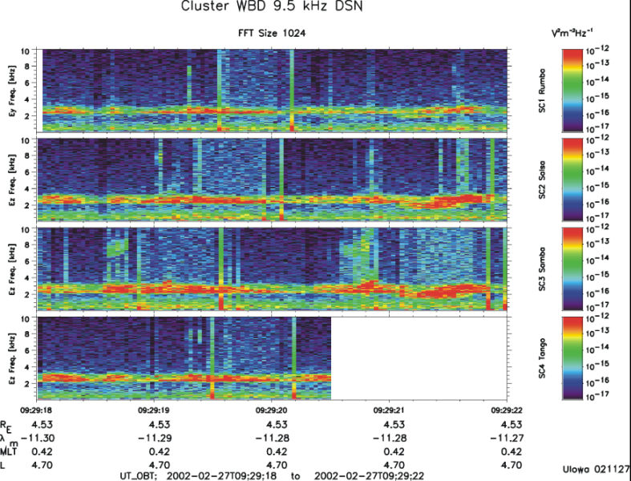
Figure 4
The reason that data appear to be missing for spacecraft 4 in Figure 4 is because a change from an electric antenna to a magnetic search coil was made at approximately 9:29:20.5. This can be seen in Figure 3 where sensor information is given in red. Figure 3 also shows clipped data following this switch for a duration of approximately a tenth of a second. The clipped data over this tenth of a second are not associated with changes in the receiver's gain even though the waveform somewhat resembles the impulses previously discussed.

Spacecraft Battery Interference
Power for the four Cluster spacecraft during eclipses and periods of peak power demand is supplied in part by five silver/cadmium batteries onboard each of the four spacecraft. It has been determined that the electrical circuits connected to these batteries create an interference in the data whose fundamental mode is approximately 65.75 kHz. Figure 5 shows this first harmonic created by the batteries onboard spacecraft 3 and 4 as a narrow horizontal line (constant frequency) residing around 65.75 kHz. Other modes in the harmonic series for this interference are readily seen in data taken from other days. For example, when WBD was set to an input frequency range of 9.5 kHz with a frequency conversion of 125 kHz on June 18, 2002, the second harmonic created by the batteries onboard spacecraft 1 was seen at a frequency of roughly 131.5 kHz in the calibrated spectrogram for this spacecraft (see Figure 6).
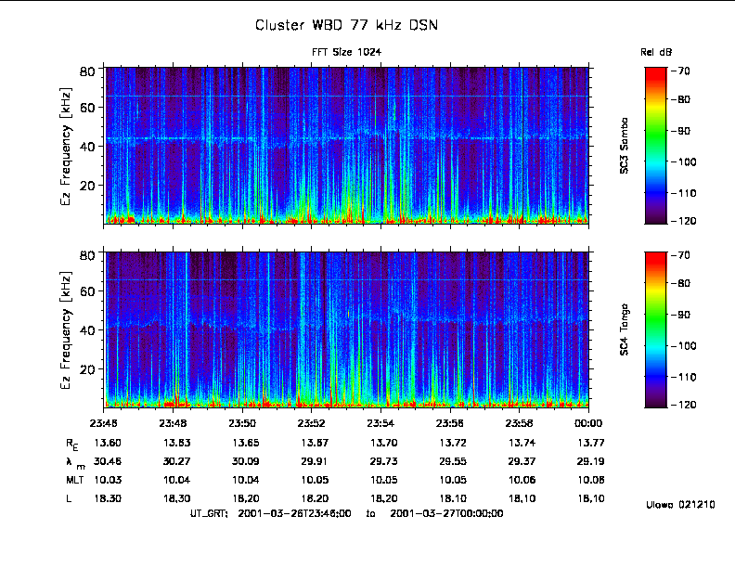
Figure 5

Spacecraft Power Bus Interference
A line of greater intensity at approximately 130.6 kHz has been repeatedly seen in the WBD data. It has been determined that this is the fundamental mode of oscillation created by the spacecraft power bus on all four cluster spacecraft. Figure 6 shows this first harmonic created by the spacecraft power bus in a calibrated spectrogram of the data collected when the wide-band receiver had an input frequency range of 9.5 kHz with a frequency conversion of 125 kHz. As expected, this fundamental mode of 130.6 kHz is the first of a harmonic series for this oscillation created by the spacecraft power bus. When the wide-band receiver has been set with an input frequency range of 19 kHz and a frequency conversion of 250 kHz, the second harmonic created by the power bus is seen at a frequency of roughly 261.2 kHz. An example of this can be seen in the data for August 7, 2002 (not shown here). Likewise, the fourth harmonic of 522.4 kHz can be seen when the wide-band receiver is set to an input frequency range of 77 kHz with a frequency conversion of 500 kHz. An example of this can be seen in the data for May 25, 2001 (not shown here).
It is worth noting that the intensity of the interference is less on spacecraft 2 and 4 than it is on spacecraft 1 and 3. More effort was put into rejecting this interference on these two spacecraft prior to launch, with time constraints preventing the same effort for the other two spacecraft.
In Figure 6 a fainter line at roughly 131.5 kHz can be seen for spacecraft 1. This is the second harmonic of the fundamental mode created by the interference associated with the electrical circuits of the spacecraft's batteries as described in the previous section.
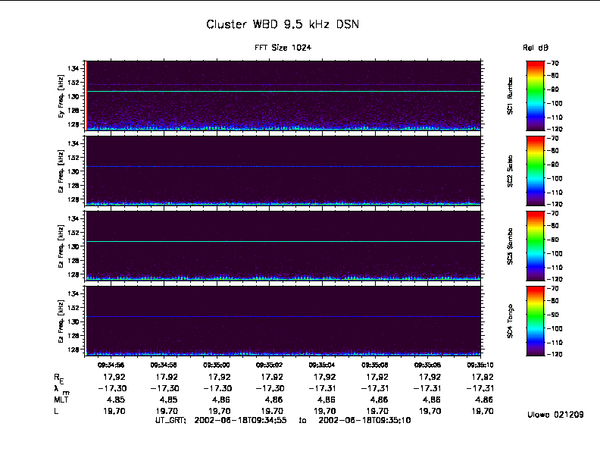
Figure 6

WHISPER Sounder Instrument Interference
WBD data clearly show when active sounding of WHISPER is taking place as seen in Figures 7 and 8 below. Figure 7 reveals that the sounding looks like consecutive impulses in a line plot of the raw count data versus time. It is plainly seen in Figure 7 that active sounding begins at approximately 10:33:36.73 for spacecraft 1, 10:33:37.53 for spacecraft 2, 10:33:37.25 for spacecraft 3, and 10:33:36.88 for spacecraft 4. Figure 8 has a smaller time domain to provide a closer look at the pulses transmitted by the WHISPER sounder. The pulses seem to occur every 26.6 milliseconds, which is one of the step duration settings for the WHISPER sounder. The step duration can also be set at 13.3, 40, 66.6, 106.6, 125, and 250 milliseconds. In all cases, the pulse emitted by the sounder has a time duration of 0.5 to 1 milliseconds.
Figure 9 shows that the sounding appears as a column of greater intensity spanning the entire bandwidth in a calibrated spectrogram. This figure also shows that the sounding lasts for three seconds on all four spacecraft. The sounding appears to have the greatest intensity for spacecraft 1. The reason for this is because the transmitter for WHISPER is connected to the shields of the Ey antenna, which happens to be the antenna used by spacecraft 1 in Figure 9. Because one of the two probes of the Ez antenna on each of spacecraft 1, 2 and 3 failed, all WBD operations on spacecraft 1 starting January 10, 2002, on spacecraft 2 starting July 8, 2007, and on spacecraft 3 starting August 6, 2002 were carried out using the Ey antenna. Thus, the active Whisper soundings that are always run using the Ey antenna of all spacecraft will almost always appear more intense in the WBD data on spacecraft 1, 2 and 3. However, since probe 4 on the Ey antenna failed on spacecraft 1 in November 2009, WBD switched back to using the Ez antenna on that spacecraft so the soundings should be less intense on that spacecraft once again. The consequence of using this antenna is that the noise floor is greatly raised since it is now half of its original length, using the one good probe 2 and the spacecraft body as the other probe (for more detail on this, see the last section on "High Noise Floor").
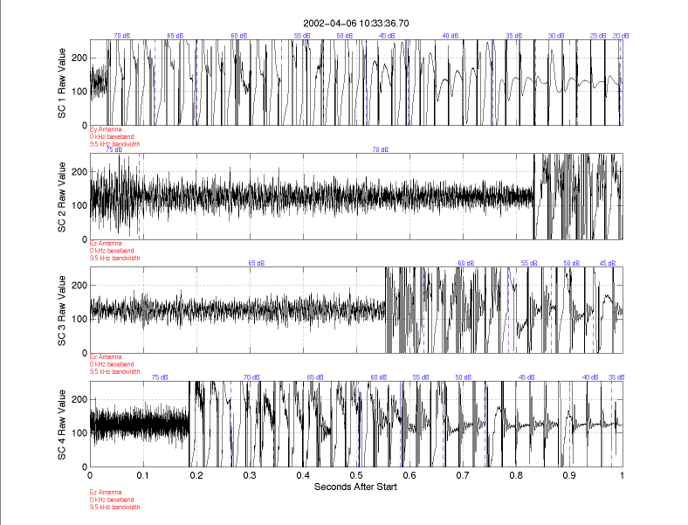
Figure 7
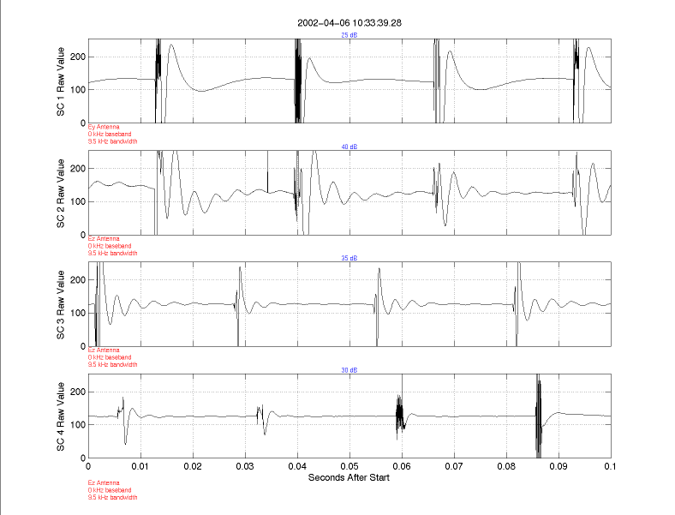
Figure 8
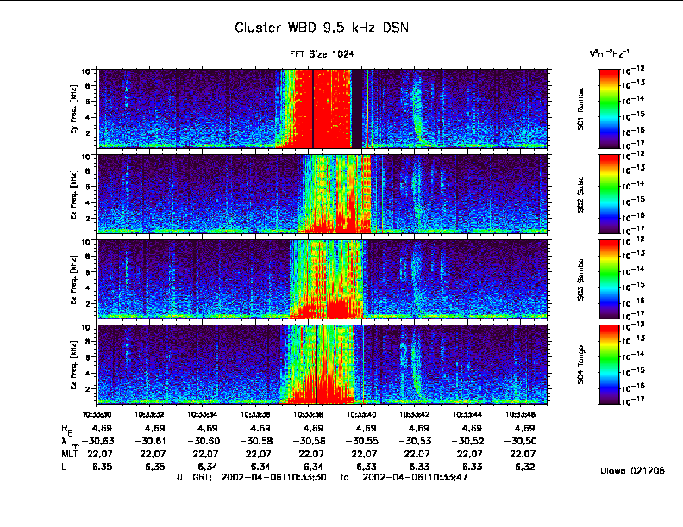
Figure 9

900 Hz Clock Effects for the Digital Wave Processor (DWP)
The DWP 900 Hz clock on all four Cluster spacecraft provides onboard timing allowing for correlation studies between the four spacecraft. Figure 10 shows two interference lines in the WBD magnetic field data for all four Cluster spacecraft. The first resides at a frequency of 900 Hz, which is the fundamental mode produced by the onboard clock. The second interference line is the second harmonic which has a value of 1.8 kHz. This interference produced by the clock is only seen in the magnetic field data.
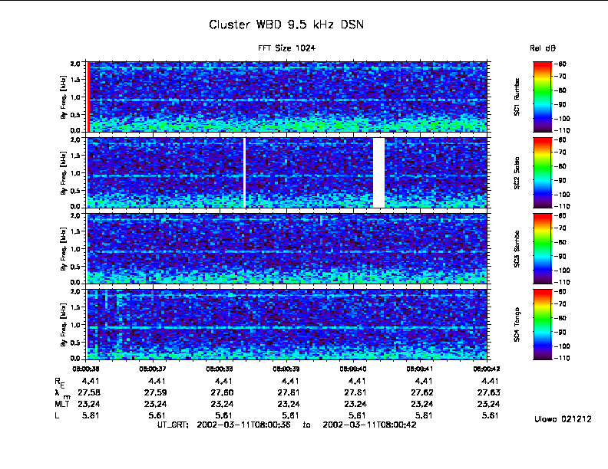
Figure 10

Interference from Electric Field Antennas
Figure 11 below shows periodic electrical interference patterns picked up by all four Cluster spacecraft on April 6, 2002. All four spacecraft were in the southern nightside magnetosphere at high latitude at the time these data were collected. These interference patterns appear to have a periodicity on the order of two seconds, which is roughly half a spin period for the spacecraft.
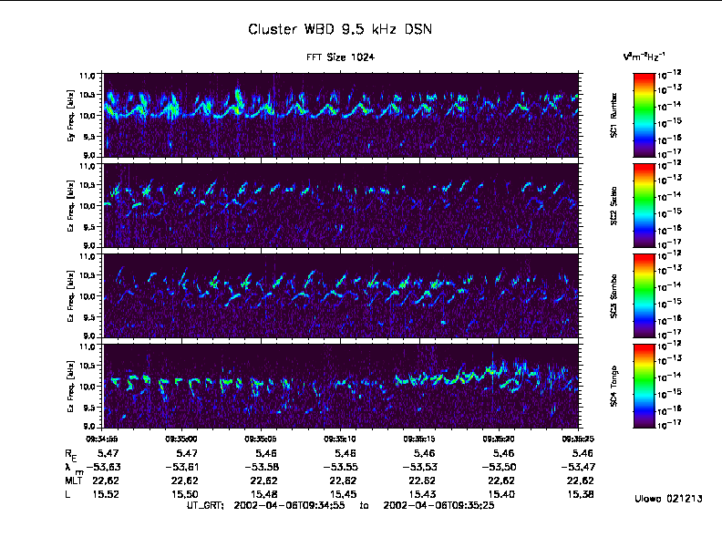
Figure 11

Figure 12 shows a more recent case of this interference on Cluster spacecraft 1, 2 and 4 on September 8, 2011 in a similar region, and persisting over many minutes. Here the interference is seen to be oscillating between more than one frequency, particularly on spacecraft 4. A high time resolution, 30 second, plot clearly exhibits this feature in Figure 13.
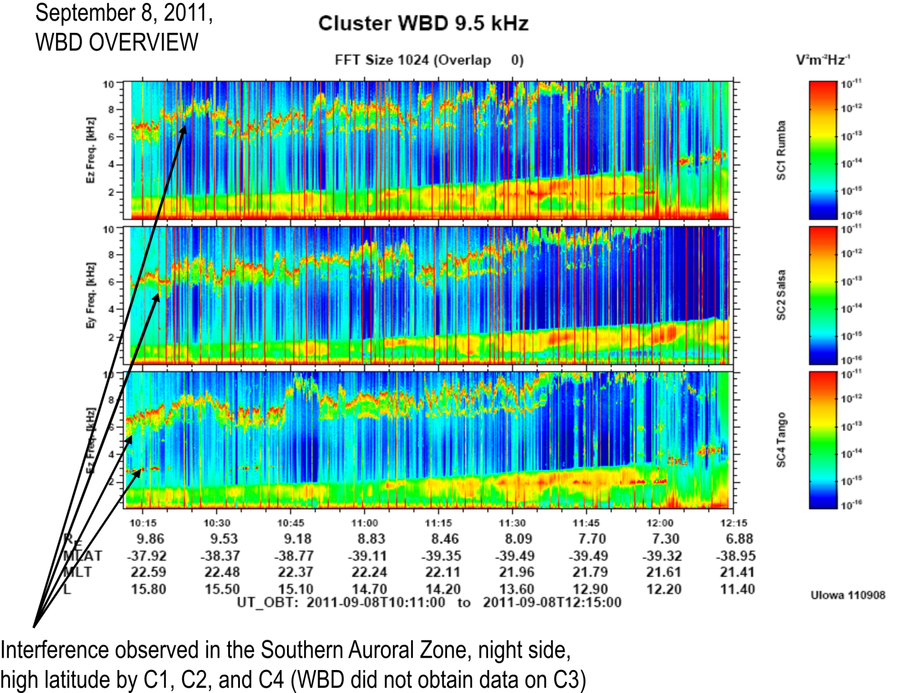
Figure 12

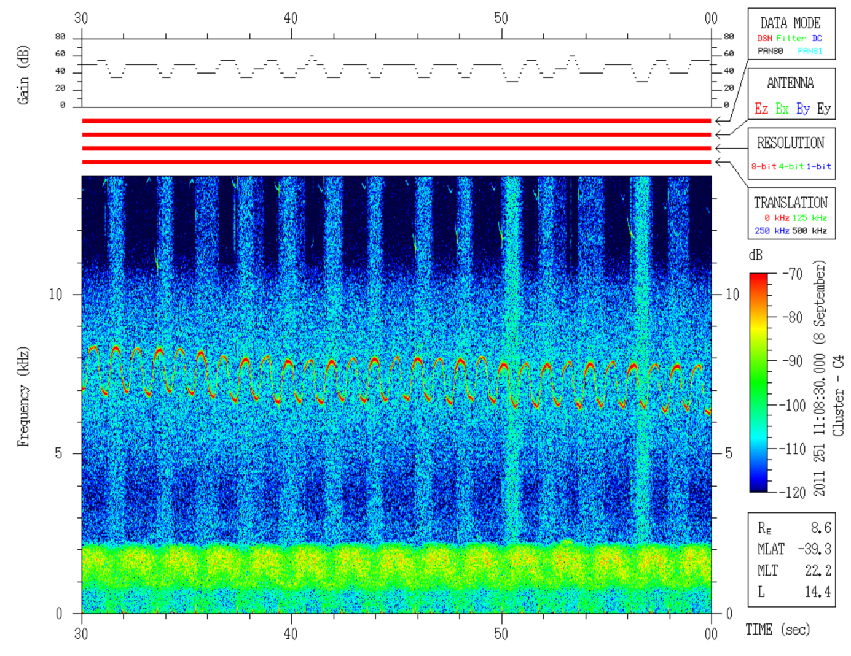
Figure 13
The interference is most likely to be observed in low density regions, night magnetic local times and high magnetic latitudes. More specifically for Cluster's orbit, these locations are:
1. 5-13 RE, 22:00 - 02:00 MLT (through midnight), 25-55 deg. Magnetic Latitude
2. 15-22 RE, 20:00 - 02:00 MLT (through midnight), 25-40 deg. Magnetic Latitude
An example of the interference observed in the far magnetotail (region 2 above) is seen in the bottom panel (spacecraft 4) of Figure 19 in the last section on "High Noise Floor". The interference is now known to be associated with the electronics within the electric field antennas (used by WBD). Changing the voltage settings of the guard, and/or the bias current settings of the probes (both components are located at the end of these antennas), can affect the intensity of the interference. Some combinations of settings can sufficiently suppress the interference. Whether the antennas are interacting with the plasma, with the resultant interference coupling through the plasma being measured by WBD (most likely), or coupling strictly onboard through the electronics (cross talk), is not known at this time. The characteristics of the probes at the end of the electric field antennas have changed over the lifetime of the mission, thus requiring infrequent changes of the guard voltage and probe bias current in order to suppress the interference. Significant changes in these settings were required on all spacecraft after the perigee of the orbit dipped below 500 km in 2011, particularly on spacecraft 2. In addition, more recently spacecraft 4 seems to be affected more than the other spacecraft, exhibiting the most variation in the periodic interference pattern and with a higher probability of occurrence. One possible reason for this is that all four probes are properly functioning in the electric field mode, which is not the case on any of the other three spacecraft. With regard to interpretation of the data, we do know for certain that these emissions are not natural plasma emissions and that the frequency of the interference sometimes correlates with the spacecraft potential (which is a proxy for electron density). Caution needs to be used when analyzing data during periods of time when these interference patterns are present.

Instrumental Effects: Waveform Distortion
The digital filters used within the WBD instrument for its three bandwidth modes (9.5, 19 and 77 kHz) and the 300 Hz boom buffer amplifier mounted within the electric antenna that WBD uses have specific response characteristics that are optimized for the detection of multi-cycle, sinusoidal type waveforms. Thus, when impulse-type waves, such as solitary waves, are detected by the WBD/electric field antenna system, some of the actual input waveforms get distorted at the output after processing through these various filters. The point (in terms of solitary wave or pulse time duration) at which the waveforms are distorted is driven by the characteristic response time of the filters, 1/(2*pi*f), where f is the RC time constant. A number of bench tests using the WBD flight spare instrument were carried out at Iowa to verify this turning point experimentally. The results of those tests can be found in the BSc thesis “WBD Response to Bipolar and Tripolar Pulses: Bench Tests vs. in Flight Observations”, by J. M. Swanner, J. S. Pickett, J. R. Phillips, and D. L. Kirchner (see https://space.physics.uiowa.edu/cluster/pulse_tests.pdfhttp://www-pw.physics.uiowa.edu/cluster/pulse_tests.pdf). For these tests, some solitary waves in the form of bipolar and tripolar pulses were input using a signal generator and the output examined in terms of shape and pulse duration. The referenced document provides some guidelines for each WBD filter mode for the maximum time duration that can be trusted for pulses that are observed with a bipolar or tripolar shape. Any pulses of this type that are observed in the data to have time durations longer than the suggested guidelines should not be used for analysis purposes other than if the researcher clearly states that these pulses, although considered to be solitary waves, cannot be characterized in terms of specific shape, time duration or amplitude. Solitary waves detected with the electric antennas are one of the types of waveforms that are manifested as broadband electrostatic noise in spectrograms created using a Fast Fourier Transform routine.

Instrumental Effects: Harmonic Generation
In many regions of space, plasma physics theory predicts the observation of waves at harmonics of natural frequencies. Some measurements of harmonics may indeed be related to natural phenomena. However, it is a well-known fact that plasma wave receivers, and amplifiers in general, can artificially introduce signals into wave data that appear to be waves at harmonics of fundamental natural frequencies.
One source of artificial harmonics in WBD power spectra is the clipping of waveforms when they exceed the amplitude range of the instrument. In the automatic gain control (AGC) mode, the WBD Plasma Wave Receiver gain state is adjusted to keep the average measured signal within the range of the digitizer. The rate at which the gain state is updated can be as fast as once every 0.1 s. However, wave amplitudes can change much more rapidly than the fastest gain update rate. This can result in occasional clipping of the waveform peaks when the wave amplitudes exceed the range of the current gain setting. The power spectra of clipped waveforms generally exhibit significant power at odd harmonics of the plasma frequency, while the even harmonics feature relatively low power. These harmonics are a purely instrumental effect [see Walker, S. N., M. A. Balikhin, I. Bates, and R. Huff, An investigation into instrumental nonlinear effects, Adv. Space Res., 30 (12), 2815-2820, 2002]. An example of a spectrogram with clipped waveforms is shown in Figure 14.
A second source of artificial harmonics is the amplifiers used in the plasma wave receiver. Harmonic generation is a problem for most amplifiers, including those used in the WBD instrument. Although the WBD design attempts to suppress instrumental harmonics, they are often present at intensity levels about 40 dB below the peak in the power spectra at the fundamental tone. In addition, harmonic generation appears to be more prevalent when the wider 77 kHz bandwidth mode is used, as opposed to the narrower 9.5 kHz and 19 kHz bandwidth modes. In order to better understand when and in what modes these harmonics are most likely to occur, comprehensive WBD bench tests were carried out to enable us to characterize which of the harmonics observed in the data are natural and which are instrument generated. The results of this are briefly touched upon in Sigsbee et al., Journal of Geophysical Research, 115, A10251, doi:10.1029/2009JA014948, Oct. 29, 2010. Researchers using WBD data thus need to be extremely cautious about their interpretation of any harmonics observed in the WBD data and should contact the WBD PI for further information.
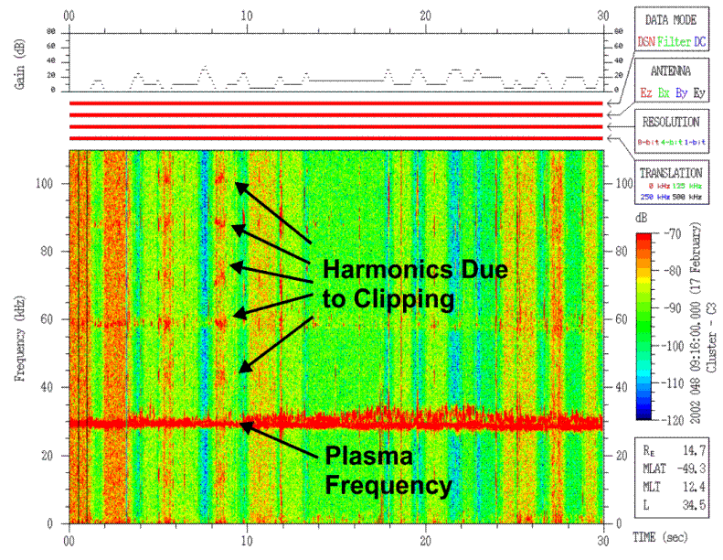
Figure 14

Saturation of Magnetic Field Data at Low Altitude
In late 2008 it was discovered that due to naturally decreasing perigee height, the Cluster spacecraft were transiting very high magnetic field regions not previously planned for or encountered in the Cluster mission before that time. In this region, the spin plane magnetic search coils (the By antennas) saturate during part of every spin such that the data cannot be calibrated. The spin axis magnetic search coil (Bx) does not suffer this saturation since it is always oriented more perpendicular to the ambient magnetic field direction in this region near perigee. The saturation of the spin plane antennas usually starts to become a problem at geocentric distances of 3.5 RE and lower. Figure 15 shows an example of this saturation in the WBD data while the By antenna was being used on spacecraft SC1, SC2 and SC4 on January 30, 2009.
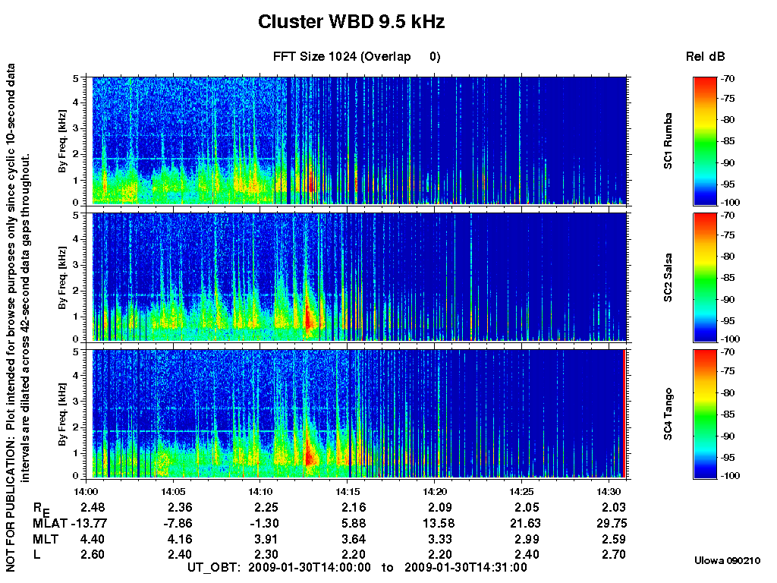
Figure 15
Intermittent vertical blue stripes covering the entire frequency range start to appear first in SC2 and SC4. By 14:15 all three spacecraft are low enough that the By antenna is in saturation during large portions of each half spin, resulting in mostly solid blue color across all frequencies in this spectrum-averaged plot. Figure 16 shows a high resolution 30-second spectrogram from SC1 starting at 14:20:00 UT. From ~14:20:11 to 14:20:21 UT the WBD receiver is using the magnetic search coil By antenna. At this time large amplitude magnetic fields are encountered twice per spin leading to saturation observed as dark blue across the entire frequency spectrum. Starting July 11, 2009, WBD began to use the Bx antenna for all of its operations below geocentric distances of 3.5 RE in order to avoid saturation. Thus, these Bx data can be calibrated and used in the interpretation of interesting plasma waves observed at these lower altitudes.
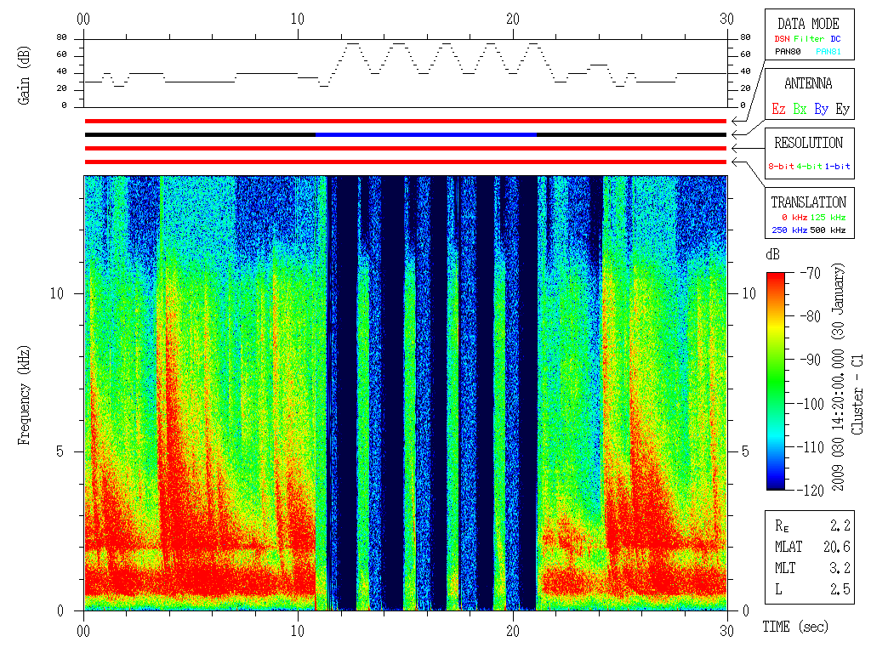
Figure 16

High Noise Floor on Cluster Spacecraft 1 Since November 30, 2009
EFW probes 1 and 2 comprise the Ez antenna while EFW probes 3 and 4 comprise the Ey antenna. These probes are the dipoles used by WBD to make its electric field measurement, taking the average potential between the two probes divided by the antenna length. The two probes on any one antenna are separated by 88 m, with the spacecraft body being in the center of the two probes. Both the Ez and Ey antennas are in the spin plane. The Ez antenna is the antenna of choice for WBD measurements because the WHISPER sounder uses the Ey antenna to carry out its soundings of the plasma and this leads to interference as discussed above. Unfortunately, the Cluster 1 EFW electric antenna probe 1 failed at the very end of 2001, requiring WBD to begin using the Ey antenna in order to get an electric field measurement with a preferred greater probe separation. In the fall of 2009, EFW probe 4 also failed on that spacecraft, thus forcing WBD to use an antenna that was half as long as before, i.e., a 44 m antenna consisting of one functioning probe and the spacecraft body as the other probe. Due to the interference on Ey caused by WHISPER, WBD switched to using the now 44m Ez antenna for its measurements on Cluster 1. Note that EFW probe failures on C2 also led to WBD using the 44m length Ey antenna after Aug. 23, 2022. See Table 2.5 above. The shorter probe separation length, however, leads to increased noise in the measurement as shown in Figure 17. Also evident in this figure are the WHISPER sounding interference for spacecraft 2 (the middle panel), which is using the Ey antenna, and interference associated with the power and battery subsystem as discussed above. Since there is a larger error bar associated with the calibrated WBD data when using the shorter 44m electric field antennas, the user of WBD data is encouraged to read the Caveats document available on the WBD website and the CSA website, as well as the WBD Calibration Report and this WBD User Guide, which is also available on the CSA website.
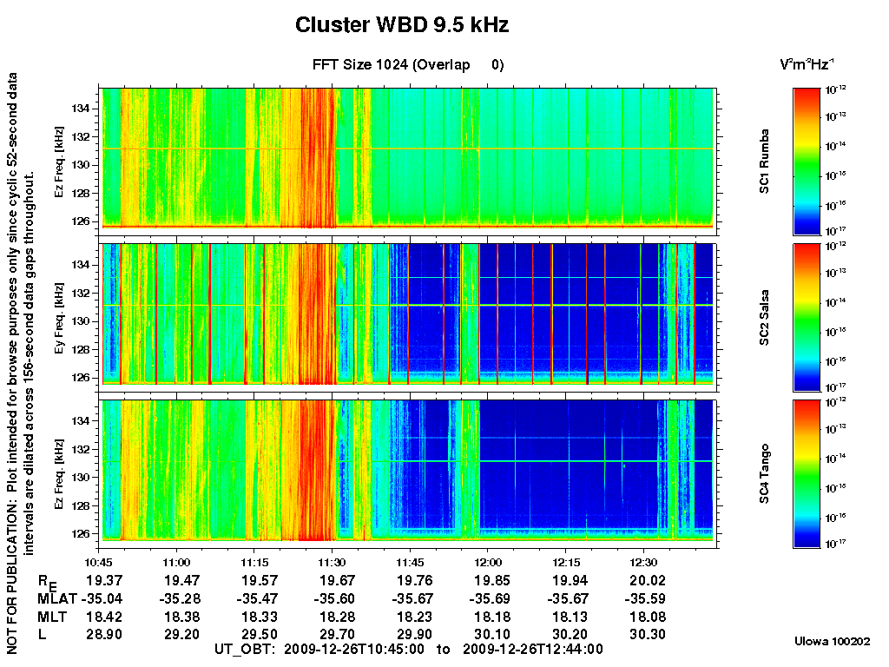
Figure 17
WBD has always created its multi-spacecraft survey spectrograms with the same color scale for the wave intensity for each spacecraft panel in order to compare the spectra with regard to intensity across the different spacecraft. However, due to this increase in the noise floor on spacecraft 1, which hides some of the details of the lower intensity waves in particular, we have decided to change the color scale, when necessary for this spacecraft in order to better bring out the details. This primarily means raising the lower end intensity by one order of magnitude when plotting the data as shown in Figure 18 (the same as Figure 17 but with the altered color scale). An "ALERT" is posted next to the spacecraft name and color bar on the right side of the affected panel to call attention to this difference.
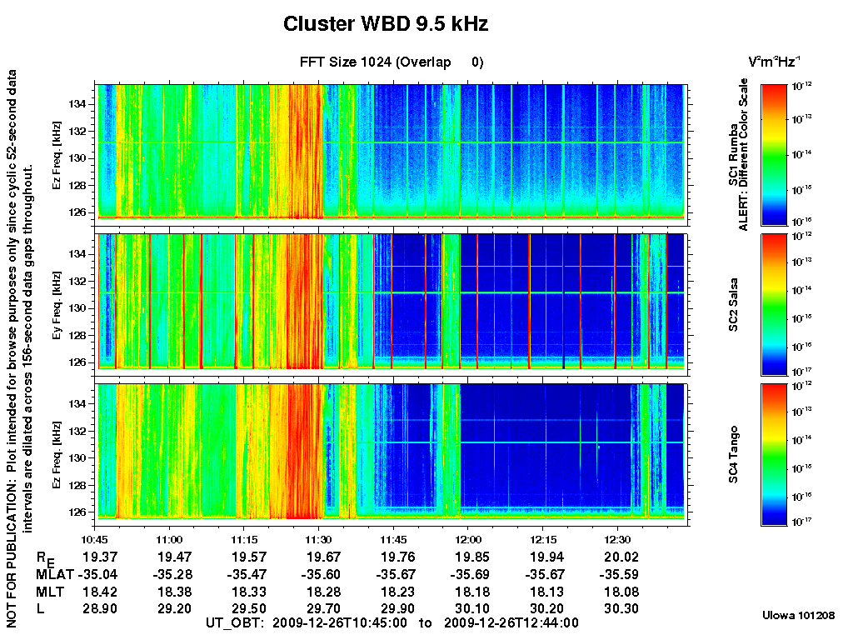
Figure 18

For some regions of the magnetosphere where primarily lower frequency (< 5 kHz), lower intensity emissions are present, this higher noise floor is most apparent. This can lead to obscuration of these naturally-occurring lower frequency emissions even with an altered color scale for C1 as shown in Figure 19. Note also the appearance in the third panel (spacecraft 4) of the interference associated with the electric field antennas discussed in the section on "Interference from Electric Field Antennas".
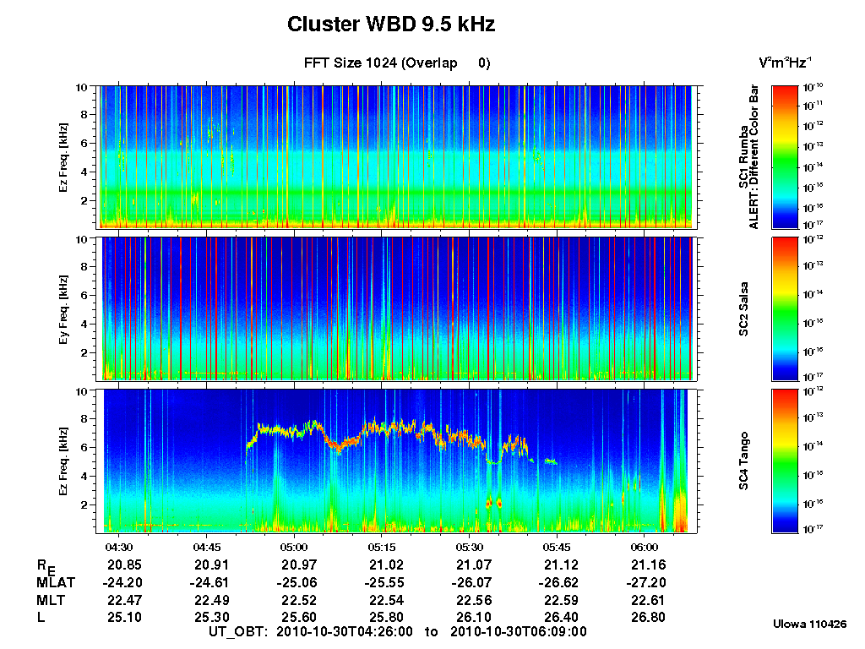
Figure 19

