Calibration Report of
the WBD Measurements
in the Cluster Active Archive (CAA)

prepared by

Jolene S. Pickett (pickett@uiowa.edu)
Roxane M. Mitten (roxane-mitten@uiowa.edu)
Ivar W. Christopher (ivar-christopher@uiowa.edu)
Joanne M. Seeberger (joanne-seeberger@uiowa.edu)

The University of Iowa
Department of Physics and Astronomy
Iowa City, Iowa, 52242, USA

and

J. Soucek (soucek@ufa.cas.cz)
O. Santolik (os@ufa.cas.cz)
M. Hayosh (hayosh@ufa.cas.cz)

Institute of Atmospheric Physics
Czech Academy of Science
Bocni II 1401, 141 00 Praha 4, Czech Republic

and

Keith Yearby (k.h.yearby@sheffield.ac.uk)
Simon Walker (simon.walker@sheffield.ac.uk)

The University of Sheffield
School of Electrical and Electronic Engineering
Sheffield, UK

Table of Contents

1 Introduction 3
2 Instrument Description 3
3 Measurement Calibration Procedures 4
4 Measurement Processing Procedures 5
A. Calibrated Time Series (Waveforms) 5
B. Calibrated Spectrogram Using an FFT 11
C. Special Processing Procedures 13
5 Results of Calibration Activities 13
6 Results of Cross-Calibration Activities 13
7 Summary 18
8 References 18
Appendix A: Frequency Response 19
Appendix B: Time Stamps 20
Appendix C: Reverse Calibration Routine 23
Appendix D: BM2 Digital Filter Characteristics 31

1 Introduction

This document describes the procedure for obtaining calibrated data values from the Cluster Wideband Data (WBD) Receiver raw telemetry values. The calibrations supplied here are first order calibrations, which are suitable for most data analysis purposes. The calibration method described below was used when creating the WBD CDF calibrated data files, which are archived at the European Space Agency (ESA) Cluster Science Archive (CSA) (https://csa.esac.esa.int/csa-web/) and at the National Aeronautics and Space Administration (NASA) Coordinated Data Analysis Web (CDAWeb) (https://cdaweb.gsfc.nasa.gov). WBD CEF (Cluster Exchange Format) files, which were created from the CDF files, are also archived at the CSA. The same calibration method has been used in the example software (CALIBRATE.C) which is available on the WBD website at https://space.physics.uiowa.edu/cluster/dvd/. Example software (R_WBD_WF.C) for reading the WBD Level 1 files, including the calibration function above, is also available on the WBD website. Software may also be available at the CSA for which this same calibration method has been employed.

2 Instrument Description

The Wideband Data (WBD) Plasma Wave Investigation for CLUSTER provides wideband (bandwidths up to 77 kHz) waveform measurements of plasma waves in the Earth's magnetosphere. A Wideband Receiver system which measures electric and magnetic fields over the frequency range 100 Hz to 577 kHz is provided by the WBD investigation as part of the Wave Experiment Consortium (WEC) instrumentation. One technique for obtaining WBD data involved transmitting band-limited waveform (time series) data, in real time, to a NASA Deep Space Network (DSN) or Czech Republic Panska Ves ground station receiving antenna using a high-rate data link. This is the unique aspect of the WBD instrument, setting it apart from the other Cluster instruments. WBD data were also obtained in a mode called Burst Mode 2 (BM2), primarily beginning in 2010. This mode involved embedding the WBD data with all other Cluster data where it was stored onboard and later played back to a European Space Agency ground receiving antenna. BM2 has drawbacks for WBD and some of the other instruments, so it was not used as frequently as the real time mode.

The primary advantage of the WBD approach is that complete, high-resolution, electric or magnetic field waveforms are available along one axis for detailed time and/or frequency analysis. For a more complete description of the WBD instrument, the user is referred to the WBD User Guide located at the CSA, and the references included at the end of that document.

3 Measurement Calibration Procedures

The WBD calibration procedure is straightforward. Apart from issues regarding the length of the electric field antenna used in obtaining scientific units of mV/m of the electric field data obtained by WBD, the calibration employed for WBD data does not change over time. Below is a flow diagram showing the steps which are carried out in calibrating the WBD data.

Extract WBD Data
Sample Set
Normalize Data to 8-bits (if 1 or 4 bit mode)
Average Data to
Obtain DC Offset
Subtract DC Offset
From Sample Set
Apply Counts/Vrms
Conversion
Apply Correction for
Gain Step
Convert to mV from V and divide by antenna length in m to get mV_{rms}/m
Apply search coil transfer function and diff. amp. gain to get nT_{rms}
Convert from rms to peak values

Magnetic Field

4 Measurement Processing Procedures

A. Calibrated Time Series (Waveforms)
The following equations are used to obtain a calibrated WBD time series, either electric or magnetic field depending on the antenna that has been selected:

Below is an explanation of how these equations are used and of the various terms therein:

(1) First a snapshot (one minor frame) consisting of 1090 raw WBD data samples (Raw Counts) is obtained from the WBD Level 1 data files (files containing the raw, uncalibrated data with time tags attached to each frame and which are available at the CSA). These data samples can be 8-bits (0-255 raw count), 4-bits (0-15 raw count), or 1-bit in size (0-1 raw count). The following calibrations are specified for 8-bit samples, so the raw counts for the 4-bit samples should be shifted up 4 bits and the 1-bit samples should be shifted up 7 bits to produce 8-bit samples for any data size. There are a number of options for the lower bits after shifting up: zeroes can be left in those bit positions, or the shifted bits can be replicated in the lower bit positions, or random noise could be inserted into those bit positions. Since the values of the lower bits are not known, any of these options are valid.

(2) Because the WBD receiver is an AC-coupled system, the 1090 raw data samples ranging from 0 to 255 represent the values of the AC field fluctuating around the zero AC field of 127.5 (1/2 of 256 for 8-bit mode) if no DC field is present. However, a small residual DC field is often present even though the WBD filters are designed to filter out the DC field. In order to remove the residual DC field from the AC measurements, the 1090 raw data samples are averaged to obtain a “DC offset” which is specific to these 1090 samples, and which should be close to 127.5 for 8-bit mode. This resulting DC offset is then subtracted from each of the 1090 samples. Removing this DC offset is necessary for the next step in the calibration procedure.

(3) The proper counts-to-Volts-rms factor is now applied to the data. This is the amplitude (in counts) of a sine wave in the middle of the passband which would be measured by the WBD receiver if a 1 Volt-rms signal were injected into the electric or magnetic differential amplifier and the WBD receiver had no gain amplifier turned on. The 1090 samples, which have been adjusted by the DC Offset, are all divided by this factor. Another way this is expressed is the decibels (dB) below a maximum amplitude sine wave, which can range from 0 through 255 for 8-bit data. This is the number of dBs below a sine wave of amplitude 127.5 counts and is referred to as dBmax. This factor depends upon the WBD mode:

Translation Mode Filter counts/V-rms dBmax
Baseband 9.5 kHz 52.5 -7.7
Baseband 19 kHz 51.0 -8.0
Baseband 77 kHz 55.5 -7.2
125 kHz 9.5 kHz 26.5 -13.6
125 kHz 19 kHz 27.0 -13.5
125 kHz 77 kHz 30.0 -12.6
250 kHz 9.5 kHz 27.0 -13.5
250 kHz 19 kHz 27.5 -13.3
250 kHz 77 kHz 30.0 -12.6
500 kHz 9.5 kHz 18.0 -17.0
500 kHz 19 kHz 18.0 -17.0
500 kHz 77 kHz 30.0 -12.6

Please note that a more accurate calibration could have been achieved by using frequency dependent tables of the amplitude calibration factor. However, a table of these adjustments was never developed due to: 1) the relatively flat response across all three passbands with rapid fall off at the band edges, and 2) the possible error associated with the gain application contributing more significantly to the overall error associated with the amplitude calibration (see last paragraph of this Section 4A on the error associated with gain). Refer to Appendix A for a description of the WBD frequency response for each passband and the estimate of the errors associated with using the frequency independent calibrations given above.

In general, the calibration procedure is the same for both real time and BM2 data. However, where BM2 is used with the digital filter in DWP, the upper bandwidth limit is determined by the digital filter characteristics provided in Appendix D rather than the frequency response given in Appendix A.

(4) Next the WBD gain amplifier value must be divided out. The gain can vary from 0 dB through 75 dB in steps of 5 dB. If the gain is G, then the 1090 samples should all be divided by 10^{G/20}.

NOTE: The next (5th) step in the calibration process is different for the electric field than for the magnetic field.

(5E) To obtain the magnitude of the electric field for the electric antennas (Equation 1), we must now multiply by 1000 (to convert Volts to milliVolts/meter) and divide by the effective antenna length, thus obtaining units of milliVolts-rms per meter. Here the effective antenna lengths are defined as the physical tip-to-tip lengths, or tip to center of spacecraft for those antennas in which one of the EFW probes have failed. The following table lists the antenna lengths that are used when calibrating WBD electric data (note that the date ranges are not necessarily indicative of the actual dates of failure of EFW probes):

S/C | Time interval | Ez antenna (P1 – P2) | Ey antenna (P3 – P4) | Comment
1 | Feb. 1, 2001 – Apr. 30, 2009 | 88m | 88 m | Ey used after Jan 10, 2002
1 | May 1, 2009 – Oct. 26, 2009 | 44 m | 88 m | Ey used.
1 | Oct. 27, 2009 – Dec. 10, 2018 | 44 m | 44 m | Ez used after Nov 30, 2009
1 | Dec 10, 2018 – end of mission (Sep. 30, 2024) | 44 m | invalid | P3 failed on 2018-12-10, Ey data is probably bad, WBD on C1 only uses Ez.
2 | Feb. 1, 2001 – May. 13, 2007 | 88 m | 88 m
2 | May 14, 2007 – Oct 12, 2015 | 44 m | 88 m | Ey used after July 8, 2007
2 | Oct 15, 2015 – Aug 23, 2022 | invalid | 88 m | Ey used after July 8, 2007
2 | Aug 23, 2022 – end of mission (Sep. 30, 2024) | invalid | 44 m | P3 failed on Aug 23, 2022
3 | Feb. 1, 2001 – Apr. 30, 2009 | 88 m | 88 m
3 | May 1, 2009 – Nov. 3, 2014 | 44 m | 88 m | Ey used after Aug. 6, 2002
3 | Nov. 4, 2014 – Apr. 28, 2024 | invalid | 88 m | After Nov. 4, 2014, both Ez probes failed and Ez data are invalid. WBD mostly uses Ey.
3 | Apr. 28, 2024 – end of mission (Sep. 30, 2024) | invalid | invalid | On Apr 28, 2024 an anomaly resulted in loss of both P3 and P4 measurements. After this, only B-field data from WBD is useful.
4 | Feb. 1, 2001 – Jul 1, 2013 | 88 m | 88 m
 | Jul 1, 2013 – end of mission (Sep. 30. 2024) | 88 m | 44 m | Only Ez used after 2013
Please be aware that the effective antenna length may differ from the physical length in some regions of Cluster’s orbit (see Beghin et al., 2005).

(5M) To obtain the magnitude of the magnetic field for the magnetic search coil antennas (Equation 2), we now apply the search coil transfer function of 1 Volt = 1 nT by dividing by 1 (in effect multiplying counts/V-rms by 1 to get counts/nT-rms), and also take into account a -6 dB gain factor in the magnetic sensor differential amplifiers by multiplying by 2, thus obtaining units of nT-rms.

(6) Finally, we multiply both equations (1) and (2) by the square root of 2 in order to obtain peak field values, as opposed to rms (root mean square) values. The units of the electric field will be mV/m peak and of the magnetic field will be nT peak.

At this point, we have a calibrated time series (for those who wish to obtain a calibrated spectrogram, see Section 2B below). The greatest error associated with the calibrated values of the WBD data resides in the gain term in the denominator of Equations (1) and (2) because the uncertainty in this term can be 1 gain step, or 5 dB (see WBD Caveats document on the WBD website https://space.physics.uiowa.edu/cluster/ under “Data & Tools” tab, or on the Cluster Science Archive website https://www.cosmos.esa.int/web/csa/documentation under “Instrument Team Documentation” for more detail on this possible error). Thus, the user should assume that the calibrated WBD electric and magnetic field values have an error bar of +/- two times the calibrated value. In reality the error in these measurements is probably much lower than this, but we provide the worst case as a guideline.

In addition, the accuracy of the time tags (Epoch variable) associated with those field values is stated to be 50 μs. This again is the worst case, since the WBD team has two different methods of obtaining the time tags, either through the ground receive times supplied by the ground station during real time operations, or through the onboard time counter that accompanies every WBD frame sent to the ground. The WBD team supplies the time tag with the best accuracy for each track based on a number of different factors. In Burst Mode 2, where the WBD data are embedded with all the other Cluster data sent to an ESA ground station, only the onboard time counter that accompanies each transfer frame is available. Refer to Appendix B and the WBD Caveats document referenced above for more information on time tags and the error associated with them.

B. Calibrated Spectrogram Using an FFT

The preferred method for obtaining a calibrated spectrogram from a calibrated time series is to use a Fast Fourier Transform (FFT). When an FFT is being used, it is very important to first check the normalization of a given FFT implementation: Apply the FFT (using a simple rectangular window) to a sine wave of amplitude A; square the real and imaginary parts of each FFT coefficient; add each resulting pair; sum over all coefficients; then take the square root of the sum. Divide the rms amplitude of the input wave (A/√2) by the above square root of the sum to obtain the FFT normalization factor. Note that the normalization factors may be different for different FFT implementations, but if the FFT is equivalent to the discrete Fourier transform in the form F_{u} =1/N ∑ f_{x} exp(i2πux/N), the FFT normalization factor is equal to √2.

To obtain a calibrated spectrogram of the WBD data using an FFT, below is a suggested series of steps that should be undertaken:

(1) Complete steps 4A(1) through 4A(5) to obtain the calibrated time series of the rms electric field or of the magnetic field if the raw, uncalibrated waveform data are being used. If the WBD calibrated time series data are obtained from the CDAWeb CDF or CSA CEF data files, proceed directly to Step 2.

(2) First reverse step 4A(6) to go back to the rms values. Apply a Hann window to a calibrated sequence of N continuous samples. Some caution should be used with regard to selecting these N samples if the data period being analyzed is from a noncontinuous mode (refer to the WBD User Guide) as it may be undesirable to apply an FFT across data points separated by a gap in time. For a Hann window the coherent gain is 0.5 (Harris, 1978). Therefore, the N samples must be multiplied by 2 if the Hann window is used. The coefficients for a Hann window are

H_{i} = 0.5 [ 1 - cos( 2πi / N ) ] for i = 0...N-1.

(3) An FFT should be performed on the N samples, ensuring that the FFT output is properly normalized (multiplied by the FFT normalization factor - refer to the first paragraph of this section B). The phase information from the FFT is not useful, so the magnitudes can now be calculated by squaring the real and imaginary parts, summing them, and taking the square root.

(4) At this point we have meaningful geophysical units: At each FFT frequency we have for the electric antennas the electric field in mV-rms/m, and for the magnetic sensors we have the magnetic field in nT-rms.

(5) Finally, to obtain spectral density, one must square the values obtained from Steps 5B(3) and 5B(4) and divide by the bandwidth, which depends upon the type of window function used before performing the FFT. If no window function is used, then the equivalent noise bandwidth is the FFT bin width, which is the sampling frequency, f_{S}, divided by the number of samples, N, sent into the FFT (f_{S}/N). Note that the sampling frequency can take on three different values depending on the WBD filter mode (Bandwidth). Refer to Table 2.4 in the WBD User Guide for these sampling frequencies. If the Hann window suggested above is used, then the equivalent noise bandwidth is 1.5 times the FFT bin width (Harris, 1978). This operation applies for both electric field and magnetic field spectral density, obtaining units of mV_{rms}²/m²/Hz or nT_{rms}²/Hz, respectively. CAVEAT: The magnetic calibrations are only valid in the range of 100 Hz to 4 kHz. The WBD receiver obtains frequency components in the passband of 100 Hz to 9.5 kHz, the filter mode that should be used when obtaining magnetic data with the search coil. However, the STAFF search coil provides calibrated data only up to its roll-off at 4 kHz. Frequency components above 4 kHz may be observed in the spectrum of WBD data, but the obtained spectral density of those frequencies is invalid.

(6) If the translation mode of the data is non-zero, then the value of that translation needs to be added to the FFT frequency that corresponds to each FFT amplitude calculated in the above steps. This shift accounts for the downconversion process that was used when acquiring such data. See the WBD User Guide, Section 2, for more information on this downconversion.

C. Special Processing Procedures

There are no special measurement processing procedures for WBD. However, some users of WBD data may be interested in the raw data values (values of 0 to 255) originally measured on the spacecraft and telemetered to the ground for initial processing by the WBD team. The WBD team has developed a routine for reversing the calibration procedure in order to obtain these raw data values. A description of the routine and a sample IDL program to carry out this reverse calibration is supplied in Appendix C.

5 Results of Calibration Activities

The results of the WBD calibration activities are the production of WBD CDF files, containing calibrated waveform (time series) data, and calibrated spectrograms of all WBD data intervals. The user is referred to the WBD User Guide archived at the CSA for a description of these calibrated data products. The CDF files that are produced are converted to CEF format at the CAA and made available for download to CSA users. The user is strongly recommended to consult the WBD User Guide, WBD Interpretation Issues, and WBD Caveats documents in order to help them analyze the WBD data and to avoid misinterpretation or misuse of the data. All of these documents are available through the CSA.

6 Results of Cross-Calibration Activities

WBD has analyzed the cutoff frequency of the L-X mode waves sometimes observed in the magnetotail where the plasma density is low, i.e., the plasma frequency lies well below 10 kHz. This cutoff frequency gives a good measure of the local plasma density for comparison with the density values obtained by PEACE. When the cutoff frequency is above 2 kHz, it can also be compared to the cutoff frequency observed in the WHISPER spectrum. Cluster traverses the magnetotail roughly in the months of June through October each year. Thus, the WBD team’s analysis of the L-X mode cutoff frequency is confined to those months each year. The comparison of the densities obtained by WBD when compared to those obtained by PEACE is sometimes quite good. The user is referred to the cross calibration section of the CSA website for more information.

Early in the mission, WBD data spectral densities were compared to those of WHISPER and STAFF in the overlapping frequency ranges resulting in some needed corrections to some of the STAFF calibrations. In addition, the electric field amplitudes in the time domain were compared between EFW and WBD, resulting in a sign correction for the WBD data, and in a time shift for the time tagging of the EFW data.

As a part of the cross-calibration activities, the comparison between WBD/WHISPER and STAFF was revisited in 2018. Comparison between WHISPER and WBD is easier, because both instruments sample the field measurements on one dipole, usually the same one. To eliminate dependence on temporal effects and spin phase, the best events for comparison are those where intense broadband signals are observed for extended periods of time. Several such events have been identified and we have reproduced the WHISPER method of calculating the spectra as closely as possible from WBD waveforms. The figure below shows a comparison of such spectra for an interval when WBD was in 9.5 kHz bandwidth mode.
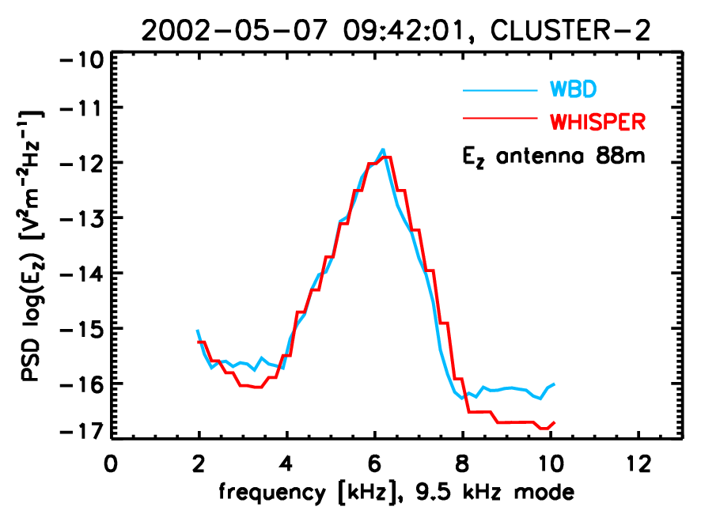
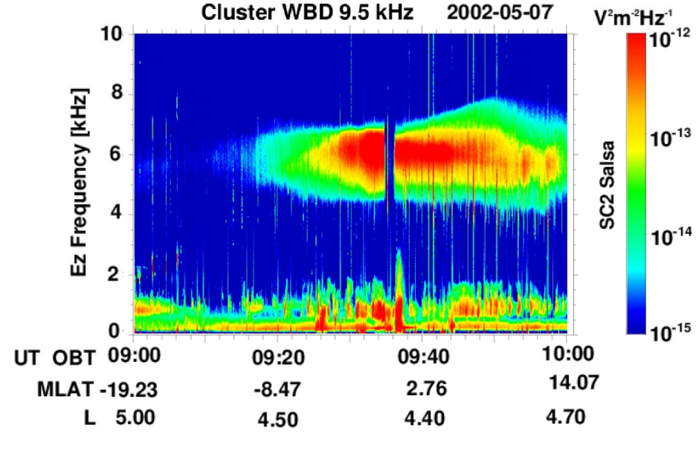
Figure 1: Comparison of WHISPER spectra with spectra calculated from WBD data. Left: WBD spectrogram. Right: Comparison of a WHISPER and WBD spectra for a single WHISPER time.
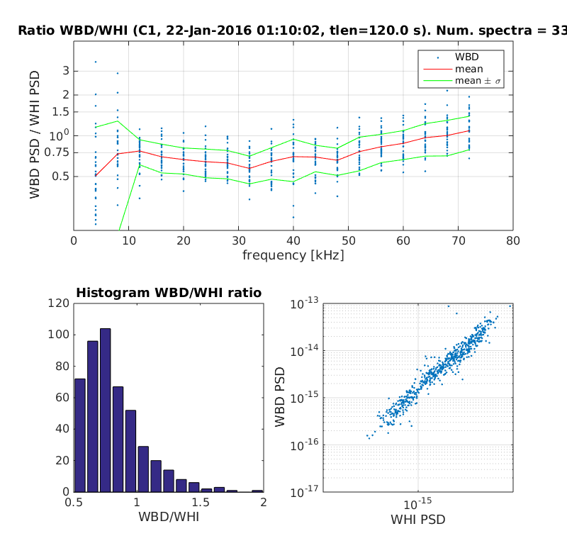
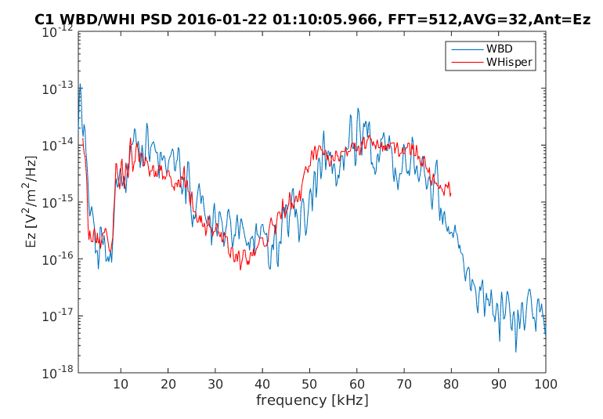
A comparison has also been performed for another event where WBD operated in 77kHz mode. See Figures 2 and 3 below.
Figure 3: A statistics of the dependence of the ratio between WHISPER and WBD spectral power as a function of frequency (top), a histogram of the ratios (bottom left) and a scatter plot of WBD versus WHISPER spectral power for all frequencies. Statistics calculated over 120 seconds.
Figure 2: A comparison of a WHISPER spectrum with an analogous spectrum reproduced from WBD data.
Similar analysis has been performed for a few other events. The results consistently show that the WHISPER and WBD spectra are consistent within a factor of 1.5.

Comparison of spectra from WBD and STAFF is more complicated due to the on-board de-spinning performed by STAFF. However, for events dominated by broadband noise, this effect shall not impact the comparison. The comparison for a selected event is shown in Figure 4 below. The spectra are consistent within a factor of 2 in spectral power.

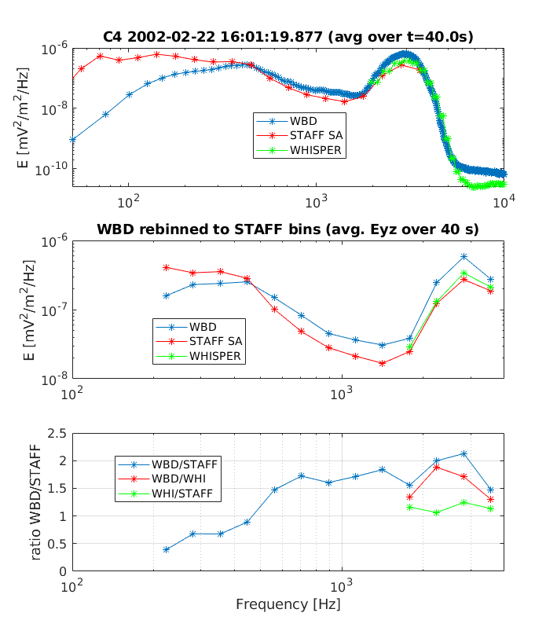
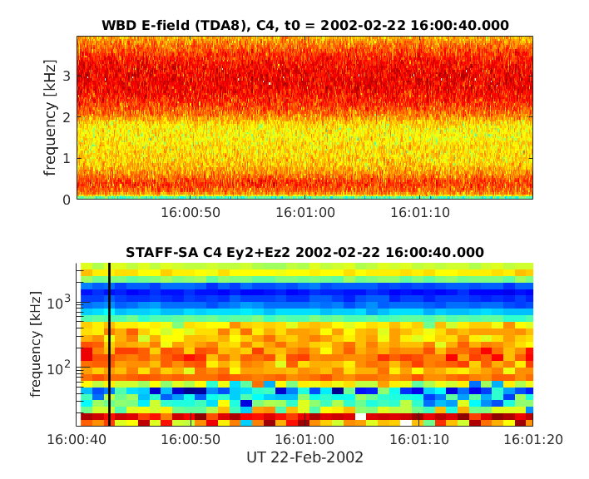
Finally, we have also attempted comparison of magnetic field spectra from STAFF-SA with spectra calculated from WBD magnetic waveforms. This can be conveniently performed using the spin axis component of STAFF-SA, which should not be affected by the de-spinning. The results for one event are shown below (averaging is done over 9 seconds – the length of the magnetic field segment of duty-cycled WBD data) in Figure 5. In this case, the WBD spectra are consistently weaker by a factor of about 2.
Figure 4: Left: Electric field spectra from WBD and STAFF-SA for a broadband event. Right: Averaged spectra from WBD, STAFF and WHISPER for the same event. The middle right panel shows the three spectra rebinned to STAFF frequency bins. The bottom right panel shows the ratios of the spectral power for all combinations of instruments.
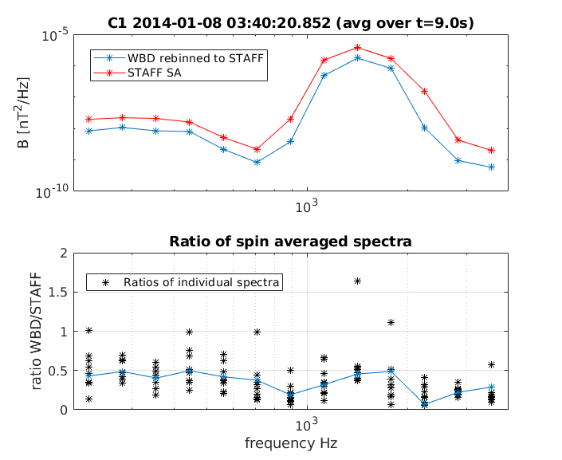
Figure 5: Comparison of B-field spectrum form STAFF-SA with a spectrum calculated from WBD magnetic waveform for the same interval, re-binned to the same spectral bins.
In conclusion, the spectra obtained from WHISPER, WBD and STAFF-SA for the same events were shown to be consistent within a factor of 2 in spectral power for almost all cases. The consistency of WBD measurements with WHISPER is better than with STAFF-SA – within a factor of 1.5.

7 Summary

The WBD time series data have been fully calibrated using the procedures described in this document. This calibration procedure and the calibration factors do not change over time with one exception. Due to failures of some of the EFW probes contained in the electric field antennas used by WBD to make its electric field measurements, the actual full tip to tip length of these antennas cannot be used, but is instead modified to half the length using the spacecraft center as one of the tips (see the table in Section 4). Calibrated time series data have been archived at the CSA along with pre-generated calibrated spectrograms of the WBD data. An estimate of the errors associated with the WBD calibrated electric and magnetic field values and the accuracy of the time tags (Epoch variables) attached to those field variables has been provided at the end of Section 4(A) above.

8 References

F. J. Harris, On the Use of Windows for Harmonic Analysis with the Discrete Fourier Transform, Proceedings of the IEEE 66 (1), 51-83, 1978.

C. Beghin, P. M. E. Decreau, J. Pickett, D. Sundkvist, and B. Lefebvre, Modeling of Cluster's Electric Antennas in Space: Application to Plasma Diagnostics, Radio Science, 40, RS6008, doi:10.1029/2005RS003264, Nov. 24, 2005.

Appendix A: Frequency Response

An analysis of the frequency response data for the WBD receiver is provided based on extensive pre- and post-launch engineering tests. The post-launch tests incorporated the additional component that is in line with the WBD measurement, an Electric Fields and Waves (EFW) boom buffer, that affects the overall frequency response, primarily on the low frequency side.

We note from the frequency response plots that resulted from the testing that the filters are flat to within a dB or less in each of the three filter passbands. All data outside of the 3-dB points should be ignored (understood to have no viable calibration). From the frequency response curves, those 3-dB points are approximately:

Translation Mode Filter 3-dB points

Baseband 9.5 kHz 100 Hz – 9.5 kHz
Baseband 19 kHz 100 Hz - 19 kHz
Baseband 77 kHz 700 Hz - 77 kHz
125.454 kHz 9.5 kHz 125.545 – 134.5 kHz
125.454 kHz 19 kHz 125.545 - 144 kHz
125.454 kHz 77 kHz 126.154 - 202 kHz
250.908 kHz 9.5 kHz 251.008 – 259.5 kHz
250.908 kHz 19 kHz 251.008 - 269 kHz
250.908 kHz 77 kHz 251.608 - 327 kHz
501.816 kHz 9.5 kHz 501.916 – 509.5 kHz
501.816 kHz 19 kHz 501.916 - 519 kHz
501.816 kHz 77 kHz 502.516 - 577 kHz

Appendix B: Time Stamps

There are two sets of time stamps provided within the WBD LEVEL1 data files. Formally, they are referred to as UT_OBT (Universal Time_Onboard Time) and UT_GRT (Universal Time_Ground Receive Time). The following describes the origin of these time stamps, their accuracies, and their preferred applications. Note that only one of these will form the basis for the Epoch time variable provided in the WBD CDF and CEF files.
UT_OBT
The origin of UT_OBT is the master ultrastable oscillator on each spacecraft, or more specifically, the counter that is incremented by it. Every WBD transfer frame (the fundamental telemetry unit from the spacecraft) contains the value of this counter at the instant at which the frame is transmitted. During ground processing, the WBD team uses this counter value plus the tcal (time calibration) files supplied by ESOC (European Space Operations Centre) to obtain the Universal Time (UT) associated with that counter value. Next, internal delays within the spacecraft (from the instant of measurement at WBD, through processing within the Onboard Data Handling System, which provides the onboard counter value and constructs the transfer frame) are calculated and applied, thus arriving at the UT time of measurement at WBD. This is referred to as UT_OBT. This time stamp will usually be within 2 milliseconds (msec) of "true" UT, as required by the specifications for OBT, but there are brief periods where UT_OBT may differ from "true" UT by up to 4 msec. The difference from "true" UT is primarily the result of slow drifts of the spacecraft oscillators, which result in the tcal files gradually losing accuracy. Once this drift results in a difference between calculated UT and "true" UT of more than 2 msec, ESOC carries out a time calibration at its ground station, and then generates revised tcal files that reset the difference back to zero.
The method used to obtain the UT_OBT time stamps for all frames in any given WBD pass (which can be anywhere in length up to about 6 hours) is to determine the time of the first full frame, and then apply a "delta time" to this for each successive frame of the pass, where "delta time" is the known time interval between frames based on the data transfer rate and the tick rate of the onboard oscillator.
In order to obtain UT_OBT time stamps with better accuracy, there are WEC (Wave Experiment Consortium) time correction files that can be obtained from the Cluster Science Archive (CSA). These files have names in the format

C#_CP_DWP_TCOR_YYYYMMDD_Vnn.cef

where # is the spacecraft number, YYYY is the year, MM is the two-digit month, DD is the two digit day, and nn is a version number. There are three columns in these files, the first containing a Date/Time string (Epoch), the second an offset value (Offset), and the third a difference value (Diff). For WBD data, only the Epoch and Diff values are needed to calculate a time correction. The data in each file are divided into blocks by rows that have the value -1.0e31 entered in both the Offset and Diff columns. Each block consists of a start and end Epoch value, with associated Offset and Diff values. To obtain the correction at a given instant, find the block that contains that instant within its bounds, and linearly interpolate between the two Diff values. The result (which may be negative) is the number of microseconds (usec) to add to UT_OBT to obtain a UT time stamp which should be accurate to +/- 10 usec.
UT_OBT is directly comparable to time stamps used by all other instruments on the Cluster spacecraft, for which the data are stored onboard and transmitted to ESA ground stations for processing. Thus, WBD UT_OBT is the most appropriate time stamp to use when comparing WBD data to that of other instruments on these spacecraft. This value was used as the Epoch time variable in the WBD CEF and CDF files archived at the CSA for the bulk of the mission, primarily after 2004.
UT_GRT
The origin of UT_GRT is the Earth Received Time (ERT) parameter applied to every WBD transfer frame that is received on the ground by Deep Space Network (DSN) and Panska Ves Observatory ground stations. ERT is the UT time at which DSN or Panska Ves received the transfer frame on the ground, and is usually accurate to within 10-50 usec. This time is then adjusted for time of flight and other data path effects to give a UT time stamp corresponding to the time of measurement at the WBD instrument, also accurate to within 10-50 usec. As mentioned above for UT_OBT, there are slow drifts within the spacecraft oscillators, and these also lead to time drifts in UT_GRT. The ESOC-supplied tcal files are used to obtain a value for the oscillator tick rate, but the actual rate will drift relative to one obtained from the tcal. Since UT_GRT is obtained by fixing the time of the first frame of a WBD data pass and then applying a "delta time" (which depends on the tick rate) to it for each successive frame of the pass (anywhere in length up to about 6 hours), any drift in the tick rate will show up as a small drift in UT_GRT over the duration of the pass. Time correction files for UT_GRT that will correct for these small drifts were never created because it was felt the magnitude of the drift was within the already expected error and because the archiving of the WBD data defaulted to using the UT_OBT time as the basis for the Epoch time variable in the CDF files after the first few years of the mission.
Occasionally, especially early in the Cluster mission (up to mid 2003) there will be WBD LEVEL1 files that contain only fill data for UT_GRT. The reason for this is that the hardware and software being used by DSN during this period would occasionally introduce time offsets into their ERT time stamps on the order of a few to tens of msec. Since there is no way to determine the
exact amount of this offset after the fact, Iowa was forced to insert fill data for the UT_GRT time stamp. In these cases, UT_OBT should be used, along with the WEC time correction files, to get accuracy of +/- 10 usec.
UT_GRT is primarily for use in performing high time-resolution comparisons between the WBD data from the various Cluster spacecraft. However, with the introduction of the WEC time correction files, a comparable level of accuracy to UT_GRT can be obtained by applying the WEC time correction to UT_OBT.

Appendix C: Reverse Calibration Routine

For anyone who wishes to work with the WBD data in its raw, uncalibrated state, i.e., with the raw data values 0 to 255 (raw counts in equations 1 and 2) as measured onboard, the following routines, written in IDL, should suffice for the purposes of reverse calibration. First, the user will need to read the WBD data from the CEF files. The generic CEF reader can be downloaded from the CAA along with the WBD data for the interval of interest.

==========================================================================

ROUTINE FOR READING CEF FILE:

;Attempt to read a Cluster WBD waveform CEF file downloaded
;from the CAA using the caa_cef_read.pro routine downloaded from the CAA.
;
;Pointers are used in this routine, but it returns a structure called wbd
;to the main program.
;
;EXAMPLE:
;Path to the CEF file and the CEF filename
;file_path='/home/kms/caa_data/cef_files/C3_CP_WBD_WAVEFORM/'
;filename='C3_CP_WBD_WAVEFORM__20020217_091600_20020217_091700_V101216.cef'
;time_range='2002-02-17T09:16:00/2002-02-17T09:17:00'
;
;file_path='/home/kms/caa_data/cef_files/C4_CP_WBD_WAVEFORM/'
;filename='C4_CP_WBD_WAVEFORM__20020121_015400_20020121_015500_V110125.cef'
;time_range='2002-01-21T01:54:00/2002-01-21T01:55:00'
;
;IDL>caa_cef_wbd_waveform_read,filename,file_path,time_range,wbd
;
;IDL> help,wbd,/struct
;** Structure WBD_DATA, 13 tags, length=92208200, data length=92208200:
; TJULDAY DOUBLE Array[1, 1646575]
; BANDWIDTH FLOAT Array[1, 1646575]
; TRANSLATION FLOAT Array[1, 1646575]
; RESOLUTION LONG Array[1, 1646575]
; ANTENNA LONG Array[1, 1646575]
; GAIN LONG Array[1, 1646575]
; ANT_BANGLE FLOAT Array[1, 1646575]
; ANT_XGSE_ANGLE FLOAT Array[1, 1646575]
; ANT_YZGSE_ANGLE FLOAT Array[1, 1646575]
; DC_OFFSET FLOAT Array[1, 1646575]
; E_WAVEFORM FLOAT Array[1, 1646575]
; B_WAVEFORM FLOAT Array[1, 1646575]
; QUALITY LONG Array[1, 1646575]

PRO caa_cef_wbd_waveform_read,filename,file_path,time_range,wbd

;Compile the caa_cef_read.pro set of routines. At the IDL command line,
;I would just type '.compile caa_cef_read' but inside a procedure I need
;to use IDL's resolve_routine procedure to do this. Trying to compile
;the routines as if they were a batch file using '@caa_cef_read' only
;works inside a main program.
resolve_routine,'cef_read',/compile_full_file,/is_function
status=routine_info()

print,status
;$MAIN$ CAANOTIFY CAA_CEF_FGM_5VPS_READ CEFREADDATA EXAMPLE1 EXAMPLE2 FILTERNAMES

;Call the routine to read the CEF file
result=cef_read(file_path+filename,trange=time_range,/julday)

;help,result
;RESULT POINTER = Array[7]

;Loop to read in the names of the variables in this file. Note that we need
;to put a * at the beginning of the variable result because it is a pointer.
for i=0, n_elements(result)-1 do print, i,': ',(*result(i)).VARNAME
;This gives the result
;INFO: Reading data records, please wait...
;% Compiled module: JULDAY.
;INFO: Finished reading /home/kms/caa_data/cef_files/C4_CP_WBD_WAVEFORM/C4_CP_WBD_WAVEFORM__20020121_015400_20020121_015500_V110125.cef
; 0: time_tags__C4_CP_WBD_WAVEFORM
; 1: Bandwidth__C4_CP_WBD_WAVEFORM
; 2: Translation__C4_CP_WBD_WAVEFORM
; 3: Resolution__C4_CP_WBD_WAVEFORM
; 4: Antenna__C4_CP_WBD_WAVEFORM
; 5: Gain__C4_CP_WBD_WAVEFORM
; 6: Ant_B_Field_Angle__C4_CP_WBD_WAVEFORM
; 7: Ant_Xgse_Angle__C4_CP_WBD_WAVEFORM
; 8: Ant_YZgse_Plane_Angle__C4_CP_WBD_WAVEFORM
; 9: DC_Offset__C4_CP_WBD_WAVEFORM
; 10: E__C4_CP_WBD_WAVEFORM
; 11: B__C4_CP_WBD_WAVEFORM
; 12: Quality__C4_CP_WBD_WAVEFORM

;Print out a few of the time tags
nparam=0
;print,(*result(0)).data(0:3)
;IDL prints out (note this was done without the /julday keyword)
;2002-01-21T01:54:00.021808104Z
;2002-01-21T01:54:00.021812659Z
;2002-01-21T01:54:00.021817214Z
;2002-01-21T01:54:00.021821769Z
;With the /julday keyword, we get the Julian days instead.

;help,(*result(0)),/struct
;** Structure <1290d284>, 67 tags, length=19761376, data length=19761369, refs=1:
; ERROR INT 0
; NGLOBAL INT 42
; NPARAM INT 1
; NREC LONG 1646575
; EOR BYTE 36
; FILE_NAME STRING 'C4_CP_WBD_WAVEFORM__20020121_015400_20020121_015500_V110125.cef'
;
;
;... and so on.

STOP

;Julian day
tjulday=(*result(0)).data

;Bandwidth and other parameters
bandwidth=(*result(1)).data
translation=(*result(2)).data
resolution=(*result(3)).data
antenna=(*result(4)).data
gain=(*result(5)).data
ant_bangle=(*result(6)).data
ant_xgse_angle=(*result(7)).data
ant_yzgse_angle=(*result(8)).data
dc_offset=(*result(9)).data

;Finally we get to the waveforms.
e_waveform=(*result(10)).data
b_waveform=(*result(11)).data

;Data quality flag
quality=(*result(12)).data

wbd={WBD_Data,tjulday:tjulday,bandwidth:bandwidth,translation:translation,$
resolution:resolution,antenna:antenna,gain:gain,ant_bangle:ant_bangle, $
ant_xgse_angle:ant_xgse_angle,ant_yzgse_angle:ant_yzgse_angle, $
dc_offset:dc_offset,e_waveform:e_waveform,b_waveform:b_waveform, $
quality:quality}

END

==========================================================================

ROUTINE FOR REVERSING THE WBD CALIBRATION TO RAW VALUES:

;+
;
; NAME: CLUSTER_WBD_REVERSE_CAL_CDAWEB
;
; PURPOSE:
;
; This routine will perform the reverse calibration on WBD electric and magnetic
; field waveform data, converting them from floating point values in mV/m or nT
; into integer or byte values from 0 to 255 counts. Currently, this routine only
; works for 8-bit digital resolution data.
;
; CATEGORY: Cluster WBD CDF Files
;
; CALLING SEQUENCE:
;
; CLUSTER_WBD_REVERSE_CAL_CDAWEB, Wbd_elec, Wbd_mag, Antenna, Bandwidth, Translation, $
; Resolution, Gain, Dc_offset, Data_quality, $
; Wbd_elec_cnts, Wbd_mag_cnts, Inverse_ecal, Inverse_bcal, Cal_fac
;
; INPUTS:
;
; Wbd_elec: The calibrated WBD electric field array from the CDF file.
;
; Wbd_mag: The calibrated WBD magnetic field array from the CDF file.
;
; Antenna: An array indicating a value for which antenna was used.
; Possible values for antenna in the CDF files, 0=Ez, 1=Bx,
; 2=By, 3=Ey.
;
; Bandwidth: The bandwidth values from the CDF files.
; Possible values of Bandwith in the CDF files are: 9, 19, 77
;
; Translation:
; The translation values (base frequency) from the CDF files.
; Possible values are: 0, 125, 250, and 500 kHz.
;
; Resolution: The digital resolution values from the CDF files. Needed to
; check to make sure that we have 8 bit data (see RESTRICTIONS
; below).
;
; Gain: The value in dB of the gain from the CDF file.
;
; Dc_offset: The DC offset value from the CDF file.
;
; Data_quality: The data quality flag (0 or 1) from the CDF file.
;
; OUTPUTS:
;
; Wbd_elec_cnts: An array containing the reverse-calibrated WBD electric field
; in counts (0 to 255).
;
; Wbd_mag_cnts: An array containing the reverse-calibrated WBD magnetic field
; in counts (0 to 255).
;
; Inverse_ecal: The value by which Wbd_elec was multiplied to obtain the reverse
; calibrated values
;
; Inverse_bcal: The value by which Wbd_elec was multiplied to obtain the reverse
; calibrated values
;
; Cal_fac: An array giving the factor that values in raw counts (minus the
; zero offset) should be multiplied by to get the calibrated value.
;
; RESTRICTIONS:
;
; This procedure does not work with 1-bit or 4-bit data. The input arrays must
; be time series arrays loaded from the CDF file. This routine will not accept
; 2-d arrays with each waveform stored according to frames, as in the WBD Level 1 files.
;
; MODIFICATION HISTORY:
;
; Written by: Kristine Sigsbee March 16, 2009
;
; Last Modified: March 17, 2009
; Added check of digital resolution.
; Added check of difference from integer values of the data arrays
; after the reverse calibration factor is applied. This has only been
; checked using a 77 kHz electric field only file. Need to check a
; file in another mode with magnetic field.
;
;-

PRO CLUSTER_WBD_REVERSE_CAL_CDAWEB, Wbd_elec, Wbd_mag, Antenna, Bandwidth, Translation, $
Resolution, Gain, Dc_offset, Data_quality, $
Wbd_elec_cnts, Wbd_mag_cnts, Inverse_ecal, Inverse_bcal, Cal_fac

;Some helpful information about the WBD receiver modes and sampling rates.
; MODE BANDWIDTH SAMPLE RATE BITS/SAMPLE DUTY CYCLE SAMPLE TIME (1090)
; 0 10Hz-9,5kHz 27.4kHz 8 100% .0397186279 sec
; 1 10Hz-9,5kHz 27.4kHz 8 100% .0397186279 sec
; 2 50Hz-19kHz 54.9kHz 4 100% .0397186279 sec
; 3 50Hz-19kHz 54.9kHz 8 50% .01985931395 sec
; 4 1kHz-77kHz 219.5kHz 8 12.5% .00496482848 sec
; 5 1kHz-77kHz 219.5kHz 1 100% .0397186279 sec
; 6 1kHz-77kHz 219.5kHz 4 25% .00992965697 sec
; 7 1kHz-77kHz 219.5kHz 8 12.5% .00496482848 sec
; sample rates are 219.54434 Khz 54.88585 Khz 27.44304 Khz
;
;Set up the matrix of calibration values (number of counts 0-255 per
;Volt RMS).
; Bandwidth
; B 9 kHz 19 kHz 77 kHz (For Modes 5,6,7?)
; a 0 kHz 52.5 51.0 55.5 55.5
; s 125 kHz 26.5 27.0 30.0 30.0
; e 250 kHz 27.0 27.5 30.0 30.0
; f 500 kHz 18.0 18.0 30.0 30.0
;

;Valid for modes 1-7
counts_per_voltrms = [[52.5, 51.0, 55.5, 55.5], $
[26.5, 27.0, 30.0, 30.0], $
[27.0, 27.5, 30.0, 30.0], $
[18.0, 18.0, 30.0, 30.0]]

;To index the matrix of counts_per_voltrms values we need the frequency translation
;and bandwidth from the WBD CDF file. Convert to integers because sometimes using
;byte arrays causes problems!
bandwidth=floor(bandwidth)
translation=floor(translation)
resolution=floor(resolution)
antenna=floor(antenna)

;We need to set up an array of indices for the bandwidths and translations.
;The lines of code below will tell us where we have different bandwidths and
;translations. Note that this does not use the last column of the counts_per_voltrms
;matrix at all! Hopefully this is okay, as the last two columns are identical.
;To seperate out modes 5,6, and 7, we will need to look at the resolution too.
;I still need to check that this works 19 and 77 kHz modes with non-zero translations.
;I also do not check for points where the bandwidth and translation are fill values.

npts=n_elements(bandwidth)
bandindex=intarr(npts)
tranindex=intarr(npts)

col0=where(bandwidth eq 9,ccnt0)
if ccnt0 gt 0 then begin
bandindex(col0)=0
endif

col1=where(bandwidth eq 19,ccnt1)
if ccnt1 gt 0 then begin
bandindex(col1)=1
endif

col2=where(bandwidth eq 77,ccnt2)
if ccnt2 gt 0 then begin
bandindex(col2)=2
endif

row0=where(translation eq 0,rcnt0)
if rcnt0 gt 0 then begin
tranindex(row0)=0
endif

row1=where(translation eq 125,rcnt1)
if rcnt1 gt 0 then begin
tranindex(row1)=1
endif

row2=where(translation eq 250,rcnt2)
if rcnt2 gt 0 then begin
tranindex(row2)=2
endif

row3=where(translation eq 500,rcnt3)
if rcnt3 gt 0 then begin
tranindex(row3)=3
endif

mycounts_per_voltrms=counts_per_voltrms(bandindex,tranindex)

;STOP

;Now let's perform the reverse of the calibration on this waveform. First we need
;find out where we have electric field data or magnetic field data. Both types may
;be found in the same file. When valid data points are not available, the quantities
;WBD_Elec and WBD_Mag are fill values (-1.00000e31).
fille=where(wbd_elec eq -1.00000e31,fillecnt)
fillb=where(wbd_mag eq -1.00000e31,fillbcnt)

valide=where(wbd_elec ne -1.00000e31 and resolution eq 8,validecnt)
validb=where(wbd_mag ne -1.00000e31 and resolution eq 8,validbcnt)

;A quick check of the file that we can do here is to see if the places where
;we have valide and valide agree with the places where we are using the E or B
;antennas. In the CDF files, 0=Ez, 1=Bx, 2=By, 3=Ey.
eantindex=where(antenna eq 0 or antenna eq 3,eantcnt)
bantindex=where(antenna eq 1 or antenna eq 2,bantcnt)

;We should have eantcnt=validecnt and bantcnt=validbcnt
if eantcnt eq validecnt then begin
print,'Check: numbers of valid WBD_Elec and Antenna=0 or 3 points agree!'
endif else begin
print,'Check Failed: numbers of valid WBD_Elec and Antenna=0 or 3 points DO NOT agree!'
endelse

if bantcnt eq validbcnt then begin
print,'Check: numbers of valid WBD_Mag and Antenna=1 or 2 points agree!'
endif else begin
print,'Check Failed: numbers of valid WBD_Elec and Antenna=1 or 2 points DO NOT agree!'
endelse

gain=floor(gain)
wbd_elec_cnts=wbd_elec
wbd_elec_float=wbd_elec
wbd_mag_cnts=wbd_mag
wbd_mag_float=wbd_mag
inverse_ecal=fltarr(npts)
inverse_ecal(*)=-1.00000e31
inverse_bcal=fltarr(npts)
inverse_bcal(*)=-1.00000e31
cal_fac=fltarr(npts)
cal_fac(*)=-1.00000e31

if validecnt gt 0 then begin

print,'Performing reverse calibration on WBD Electric Field...'

;Get the reverse calibration factor.
inverse_ecal(valide)=(88.0*mycounts_per_voltrms(valide)*(10.0^(gain(valide)/20.0)))/(sqrt(2.0)*1000.0)
wbd_elec_float(valide)=(inverse_ecal(valide)*wbd_elec(valide))+dc_offset(valide)
wbd_elec_cnts(valide)=round((inverse_ecal(valide)*wbd_elec(valide))+dc_offset(valide))
cal_fac(valide)=(sqrt(2.0)*1000.0)/(88.0*mycounts_per_voltrms(valide)*(10.0^(gain(valide)/20.0)))

endif else begin

print,'All WBD Electric Field values are fill.'
wbd_elec_cnts(*)=-1.00000e31

endelse

if validbcnt gt 0 then begin

print,'Performing reverse calibration on WBD Magnetic Field...'

inverse_bcal(validb)=(mycounts_per_voltrms(validb)*(10.0^(gain(validb)/20.0)))/(2.0*sqrt(2.0))
wbd_mag_float(validb)=(inverse_bcal(validb)*wbd_mag(validb))+dc_offset(validb)
wbd_mag_cnts(validb)=round((inverse_bcal(validb)*wbd_mag(validb))+dc_offset(validb))
cal_fac(validb)=(2.0*sqrt(2.0))/(mycounts_per_voltrms(validb)*(10.0^(gain(validb)/20.0)))

endif else begin

print,'All WBD Magnetic Field values are fill.'
wbd_mag_cnts(*)=-1.00000e31

endelse

;Here are some example diagnostic checks!!!!
;
;Check to see if we have done a decent job of reverse calibrating by comparing
;the CDF data quality flag with the locations of clipped (0 or 255 counts) data.
;If everything worked okay, we should have clipcnt1=clipcnt2+clipcnt3
clipped1=where(data_quality eq 1,clipcnt1)
clipped2=where(wbd_elec_cnts eq 0 or wbd_elec_cnts eq 255,clipcnt2)
clipped3=where(wbd_mag_cnts eq 0 or wbd_mag_cnts eq 255,clipcnt3)

;Check to see how close the values were to integers before we rounded them.
;For the test case, there were 16443740 data points and only 293708 (or 1.79%)
;had non-integer results (nonzero reverse_cal_diff) after the reverse
;calibration factor was applied. The maximum difference was 3.05176e-05,
;the minimum difference was -2.28882e-05, and the average difference was -8.69528e-08.
;Since these are extremely small, we can conclude that the reverse calibration works
;quite well!

if validecnt gt 0 then begin
reverse_cal_diff1=wbd_elec_float-wbd_elec_cnts
nonzero_diff1=where(reverse_cal_diff1 ne 0,diffcnt1)
maxdiff1=max(reverse_cal_diff1,maxdiffind1)
mindiff1=min(reverse_cal_diff1,mindiffind1)
avgdiff1=total(reverse_cal_diff1)/float(n_elements(reverse_cal_diff1))
endif

if validbcnt gt 0 then begin
reverse_cal_diff2=wbd_mag_float-wbd_mag_cnts
nonzero_diff2=where(reverse_cal_diff2 ne 0,diffcnt2)
maxdiff2=max(reverse_cal_diff2,maxdiffind2)
mindiff2=min(reverse_cal_diff2,mindiffind2)
avgdiff2=total(reverse_cal_diff2)/float(n_elements(reverse_cal_diff2))
endif

STOP

END

==========================================================================

Appendix D: BM2 Digital Filter Characteristics

Data acquired in Burst Mode 2 may be subject to digital filtering in DWP to reduce the bandwidth and allow the sampling rate to be reduced by decimation to 1/3 or 1/4 of the WBD instrument rate. The digital filter is only valid for use with the 9.5 kHz 8 bit instrument mode, but may be used with both baseband and frequency translated modes. The digital filter sets a new (lower) high frequency bandwidth limit, while the low frequency -3dB point as listed in Appendix A above still applies.

Three different filter responses have been used: original (non-optimised), optimised /3, and optimised /4. The optimised filters were used for data acquired on and after 2013 August 23, with the filter used indicated by the BM_Mode parameter in the CDF files. The characteristics of each filter are given in the following tables and charts.

Note that in the case where the original filter is used in divide by 4 mode, the usable bandwidth is determined by the risk of aliasing rather than the filter passband. In other words, energy may be present in the spectrum above the specified usable bandwidth, but we cannot be sure whether it is actually at the frequency where it appears or if it is a higher frequency reflected down.

Table 1. WBD digital filter characteristics.
Implementation | Sampling  rate fz (kHz) | Pass band  fp (kHz) | Stop band  fs (kHz) | Usable bandwidth (kHz) | BM_Mode
Original in /3 mode | 9.148 | 3.860 | 4.500 | 3.860 | 6
Original in /4 mode | 6.861 | 3.860 | 4.500 | 2.361 | 8
Optimised /3 | 9.148 | 4.254 | 4.912 | 4.236 | 7
Optimised /4 | 6.861 | 3.101 | 3.787 | 3.074 | 9

Table 2. WBD digital filter coefficients. The table shows the integer coefficients used in the DWP onboard software. The filter is symmetrical of length 2N, where N is 29, such that the coefficient at index 30 is the same as that at index 29, and so on. Error! Not a valid link.
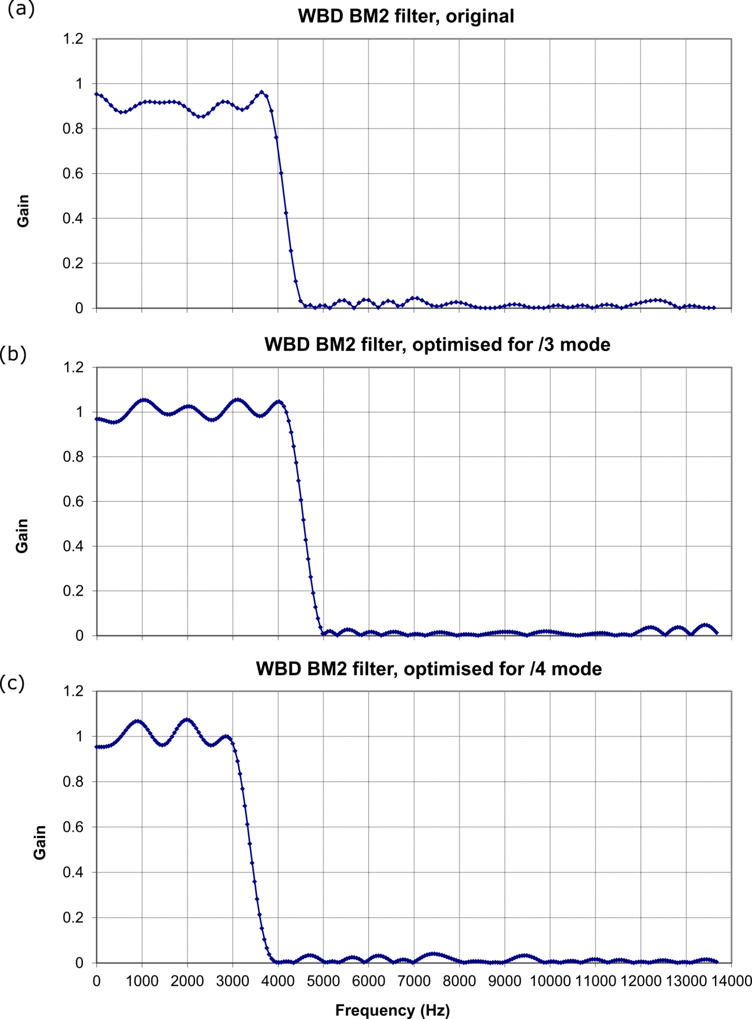

Figure 1. WBD filter gain as a function of frequency. Panel (a) original filter, (b) optimised /3, (c) optimised /4.

Magnetic calibration is only valid in the range of 100 Hz to 4 kHz.

